**For more information: Press Release**

**JBL Greece ( Official Distributor WaveMotion S.A)** For direct publication.

Tel.:210-9244505 Date:01/11/24

Email: [jbl_greece@wavemotion.gr](mailto:jbl_greece@wavemotion.gr)

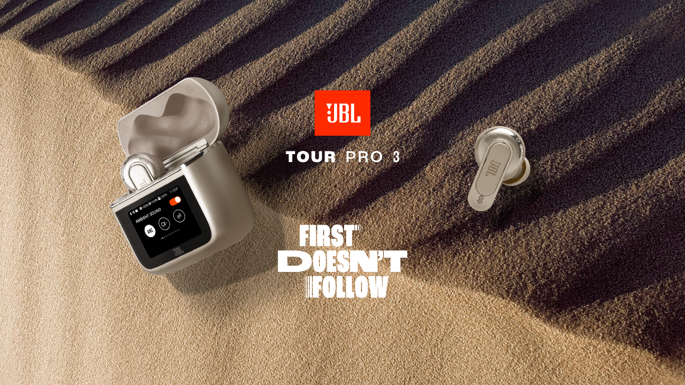

**First doesn’t follow - Enjoy entertainment anywhere with JBL Tour Pro 3 headphones!**

Athens – November 1st, 2024. WaveMotion S.A., the official distributor of JBL for the Greek market, launches the JBL Tour PRO 3, the most advanced True Wireless Stereo (TWS) headphones. With dual drivers, innovative JBL Spatial 360 with Head Tracking, True Adaptive Noise Cancellation 2.0, and the most advanced Smart Charging Case™, these headphones bring together truly unique features, redefining the listening experience.

**Comfort without limits and entertainment everywhere.**

The Smart Charging Case™ not only provides full control over headphone functions but also serves as a wireless audio transmitter, allowing us to enjoy “entertainment everywhere” from any source, analog or USB, such as an in-flight entertainment system. Simply connect the charging case to the source for instant and automatic connection with the headphones. Even better, the direct connection between the case and headphones is more stable and has lower latency than Bluetooth, making the JBL Pro Tour 3 an ideal companion for gaming, calls, movies, and music.

The JBL Tour PRO 3 is JBL’s first TWS model with full Auracast™ functionality. Easily share audio content with any device using the Auracast™ button on the Smart Charging Case™ screen. Now, you can connect to an existing broadcast simply by selecting the option on the case and its companion app. The advanced Smart Charging Case™ features a screen 30% larger than its previous version, all in a smaller, pocket-friendly design. The screen provides full control over music playback, call management, access to ID3 Tag information, caller ID, media files, and much more—all without needing to access your phone.

**Immersive JBL Spatial 360 with Head Tracking**

The JBL Tour PRO 3 introduces JBL Spatial 360 technology with Head Tracking, transforming stereo sound into a fully immersive experience, especially when watching movies or gaming. Head Tracking enhances immersion by creating the sensation that all sounds come from the surrounding environment, with you at the center of the soundstage, even as you move.

Whatever you're listening to, enjoy it in exceptional quality. The JBL Tour PRO 3 features a hybrid dual-driver system in each earbud—a first for JBL TWS—delivering JBL’s legendary Pro Sound. The dedicated driver handles high notes with enhanced clarity, freeing the 11 mm dynamic driver to deliver powerful, clearer bass and vibrant vocals.

**Customized Listening Experience**

Most features of the JBL Tour PRO 3 are fully customizable, including the True Adaptive Noise Cancellation 2.0 technology, which adapts to environmental changes and compensates for sound leakage. For optimal performance, the JBL Tour PRO 3 comes with a wide variety of ear tips—choose from five different sizes of silicone tips and an additional foam set to find your perfect fit. With six microphones and a hydrodynamic wind-resistant design, the Tour PRO 3 ensures clear, unfiltered voice transmission during calls.The headphones utilize a new calling algorithm, JBL Crystal AI, to enhance clarity even in noisy environments. Your voice will be clear not only in areas with consistent low-frequency noise, such as traffic and subway stations, but also in high-frequency, busy settings like cafés.

Enhance your call experience with the new Voice Call smart equalizer, which features an audio level optimizer to reduce the volume of loud speakers or boost the volume of quiet ones. Additionally, the Tour PRO 3 allows users to personalize the lock screen and wallpaper with any photo of their choice, supporting display commands in 13 languages.

Available in two colors: classic black and elegant latte.

More information can be found at

[Home | JBL (jblgreece.gr)](https://www.jblgreece.gr/)

and our social account [Facebook](https://www.facebook.com/JBLGreece) ,  [Instagram](https://www.instagram.com/jbl_greece/), [Tiktok](https://www.tiktok.com/@jbl_greece?lang=en)

**About WaveMotion**

WaveMotion, an importer and distributor, is seated in Athens Greece, operating on a wholesale basis, in the consumer electronics, telecommunications and computer industry for over 35 years. WaveMotion S.A. retains the official, exclusive, distribution for the Greek market of important Houses- in leading positions in the Global Arena, like JBL, harman/kardon, Cambridge Audio, Q Acoustics, QED, Goldring, rapoo, Native Union, Livall. Brand Development is the core skill of WaveMotion Team. The vision of our people is to expand WaveMotion’s Brands selection, following our tagline’s principles –Technology, Aesthetics, Design- and continue this journey of Ours, introducing compellingly and establishing decisively these Brands, in the eyes of our Customers.

**About HARMAN**

HARMAN (harman.com) designs and engineers connected products and solutions for automakers, consumers, and enterprises worldwide, including connected car systems, audio and visual products, enterprise automation solutions; and services supporting the Internet of Things. With leading brands including AKG®, Harman Kardon®, Infinity®, JBL®, Lexicon®, Mark Levinson® and Revel®, HARMAN is admired by audiophiles, musicians and the entertainment venues where they perform around the world. More than 50 million automobiles on the road today are equipped with HARMAN audio and connected car systems. Our software services power billions of mobile devices and systems that are connected, integrated and secure across all platforms, from work and home to car and mobile. HARMAN has a workforce of approximately 30,000 people across the Americas, Europe, and Asia. In March 2017, HARMAN became a wholly-owned subsidiary of Samsung Electronics Co., Ltd..