**For more information: Press Release**

**WaveMotion S.A** For direct publication

Τηλ.:210-9244505 Hμ.: 06/9/2023

Email: [Partners@WaveMotion.gr](mailto:Partners@WaveMotion.gr)

**XGIMI Unveils the MoGo 3 Pro :**

**The Ultimate Portable Smart Projector**

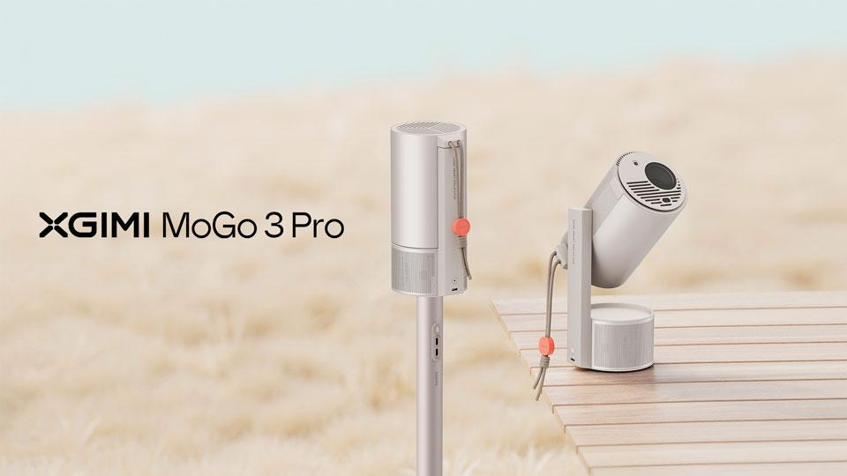

Athens – Ocrober 23th 2024 – WaveMotion S.A., the official distributor of XGIMI in Greece, introduces the innovative smart projector brand, set to revolutionize home entertainment and outdoor portable cinema with the launch of its latest portable projector, the MoGo 3 Pro. This cutting-edge projector offers an unparalleled viewing experience, combining a compact size with remarkable versatility

**Iconic Design, Functionality, and Portability in One**

XGIMI is bringing iconic design, functionality, and portability to the forefront, with the MoGo 3 Pro measuring almost the exact height as a Starbucks Venti Cup. Weighing only 1.1kg, the MoGo 3 Pro is lightweight and compact and delivers intelligent features paired with cinematic visuals and sounds. Its USB Type-C port allows it to be powered by a power bank (65W minimum), making it perfect for on-the-go use. Whether you're setting up an outdoor movie night or a presentation on the fly, the MoGo 3 Pro is ready to deliver. It is also XGIMI’s first GoogleTV projector and offers native Netflix support alongside a variety of other popular streaming applications.

**High-Quality Visuals Paired with Immersive Audio**

MoGo 3 Pro features a high-quality LED light source and a brightness of 450 ISO lumens, ensuring vibrant and clear images. With a resolution of 1080P and the ability to project up to a 120-inch screen, the MoGo 3 Pro turns any space into a cinematic venue, whether at home or outdoors. This versatility is supported by one of its standout features: The integrated hidden bracket. It allows for a 130° tilt, making it easy to adjust the projection angle to suit any scenario.

Experience 360-degree surround sound at a whole new level thanks to the built-in 2 * 5W Harman/Kardon speakers. These speakers provide rich, immersive audio that enhances the viewing experience. The MoGo 3 Pro is the ultimate tool for those who thrive from hosting, as the new ‘Ambient Light Mode’ allows the projector to also be used as a Bluetooth speaker. Paired with a smartphone, this mode unleashes an unforgettable ambiance and immerses you in your favourite music.

On the heels of its 2024 EISA recognition as “Best Portable Projector”, XGIMI is also introducing three innovative accessories to complement the MoGo 3 Pro: the Creative Optical Filter, that allows users to create stunning immersive atmospheres with the XGIMI Wall application; the PowerBase Stand, a 2-in-1 stand that doubles as a charger with its built-in battery (up to 2h30 of autonomy); and the Carrying Case, a stylish carrying case for easy transport and protection.

**Hassle-Free Setup with Intelligent Screen Adaption 2.0**

Setting up the projector is a breeze, thanks to XGIMI’s advanced image correction technology, ISA 2.0. This system automatically corrects keystone distortion, performs autofocus, avoids obstacles, protects the eye and aligns the picture perfectly to the screen, ensuring a hassle-free setup every time.

**Availability and Pricing**

The MoGo 3 Pro will be available for purchase at 549,00€ on [WaveMotion Gallery](https://wavemotiongallery.gr/)[,](https://www.amazon.co.uk/stores/XGIMIUK/XGIMIUK/page/1CF4B835-2834-4879-A500-7A4E962A74AA) and other authorized retail channels. The projector will also be available as a bundle with the exclusive PowerBase Stand at an attractive price point of 629,00€. All accessories will be available separately as well.

For more information, please visit [XGIMI - Wavemotion](https://www.wavemotion.gr/el/our_brands/xgimi/).

Find us on Instagram : [XGIMI Technology Greece & Cyprus (@xgimitech_gr_cy)](https://www.instagram.com/xgimitech_gr_cy/)

**About WaveMotion**

WaveMotion, an importer and distributor, is seated in Athens Greece, operating on a wholesale basis, in the consumer electronics, telecommunications and computer industry for over 35 years. WaveMotion S.A. retains the official, exclusive, distribution for the Greek market of important Houses- in leading positions in the Global Arena, like JBL, harman/kardon, Cambridge Audio, Q Acoustics, QED, Goldring, rapoo, Native Union, Livall. Brand Development is the core skill of WaveMotion Team. The vision of our people is to expand WaveMotion’s Brands selection, following our tagline’s principles –Technology, Aesthetics, Design- and continue this journey of Ours, introducing compellingly and establishing decisively these Brands, in the eyes of our Customers.

**About XGIMI Technology**

Since 2013, the state-of-the-art XGIMI projectors have helped countless people worldwide to

create genuinely immersive audio-visual experiences. Working with reputable partners like

Google, Harman Kardon, Dolby Vision, and Texas Instruments, XGIMI builds all-in-one entertainment devices,perfected due to their user-oriented philosophy. Through industry-leading innovation,

streamlined setups, and unique designs, XGIMI always strives to develop the best home and

portable projectors for everyone to enjoy.