**For more information: Press Release**

**JBL Greece ( Official Distributor WaveMotion S.A)** For direct publication.

Tel.:210-9244505 Date:03/09/24

Email: [jbl_greece@wavemotion.gr](mailto:jbl_greece@wavemotion.gr)

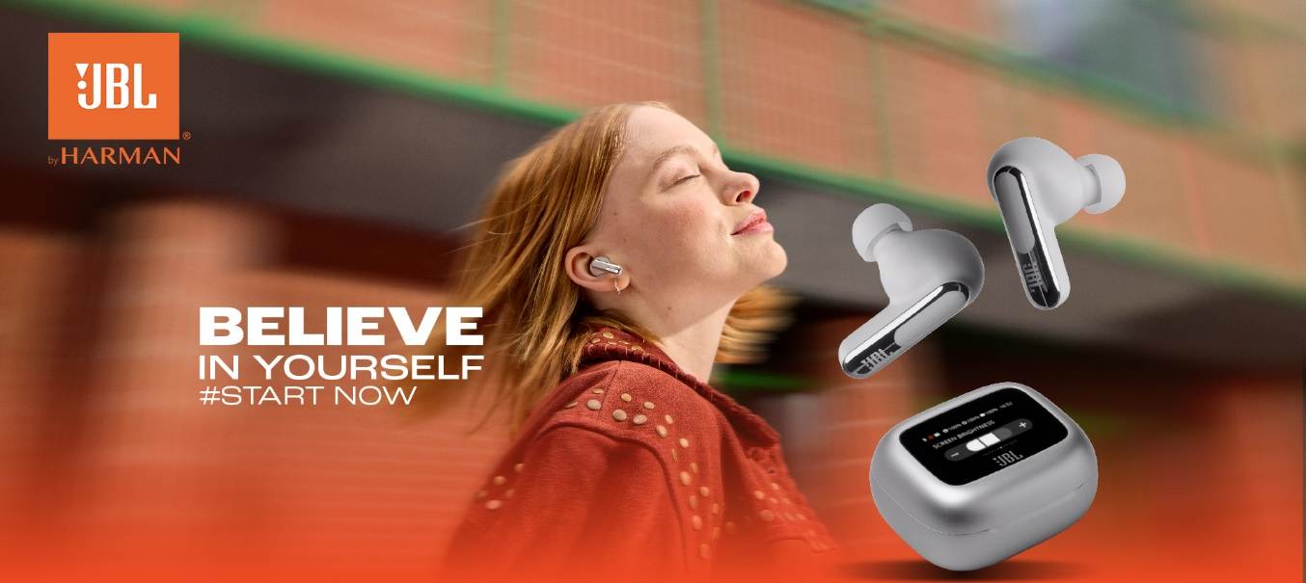

**JBL Believe in Yourself**

**Start Now - Season 2!**

Athens – September 3rd, 2024. WaveMotion S.A., Official Distributor for the Greek market, of JBL lifestyle audio products presents for the second year in a row its campaign "Believe in yourself – Start now!" Last year, JBL believed in you and other than the million views and positive comments it collected with this particular campaign, it managed to inspire a significant number of people to follow their dreams and goals. The campaign "Believe in yourself – Start now!" continues this year as well, aiming for even more people being able to pursue their dreams.

**Are you ready to start?**

Having the strongest player in the sound department as your ally, you can claim what you dream and want from the beginning. It's time to set your mid-year's resolutions. Whether that means claiming everything you've been putting off until now, or leaving behind your fears, every new beginning means believing in yourself first and foremost. No matter how scary every new start seems at first glance, sooner or later you realize that what you need the most is having someone by your side who believes in you.

JBL once again proves to be the most reliable companion, boosting the volume of every big and small goal of yours with top products created for you!

Fall means reading, it means stress, exams. Concentrate on your goals with our noise canceling function of JBL headphones. Fall means big sporting events. Bet on your team and leave the sound to JBL, with speakers and soundbars that offer legendary sound quality to fully feel every small and big victory. Every September also means a new beginning. Clip your speaker on your bag and start your short and long journeys of every day without fear of rain, because with JBL and its waterproof products, nothing can stop you.

New beginnings bring both joys and disappointments – let’s be honest. Put on your headphones, take your time and leave the noise of the world away for a while with JBL headphones. And when you feel ready, JBL will be there again to give the volume to everything you want to share and express.

The campaign is based on storytelling. Each JBL product supports a different goal, a different person, a different story. That is why the title of each photo changes: Start Living, Start Discovering, Start Playing, Start Loving etc. The main message "Believe in yourself" always remains the same. The campaign will feature people who started, tried, succeeded and today serve as role models. They will talk about their journey and inspire us with how they believed in themselves and succeeded.

The purpose is to spread the message that, if you believe in yourself, you can achieve a lot! So whatever your goal is, JBL is here to help you achieve it.

Start now! And if you fail start again, cause someone is always going to be there supporting you!

Have a good beginning with JBL!

**#JBL_Believe_in_yourself**

More information can be found at

[Home | JBL (jblgreece.gr)](https://www.jblgreece.gr/)

and our social account [Facebook](https://www.facebook.com/JBLGreece) ,  [Instagram](https://www.instagram.com/jbl_greece/), [Tiktok](https://www.tiktok.com/@jbl_greece?lang=en)

**About WaveMotion**

WaveMotion, an importer and distributor, is seated in Athens Greece, operating on a wholesale basis, in the consumer electronics, telecommunications and computer industry for over 35 years. WaveMotion S.A. retains the official, exclusive, distribution for the Greek market of important Houses- in leading positions in the Global Arena, like JBL, harman/kardon, Cambridge Audio, Q Acoustics, QED, Goldring, rapoo, Native Union, Livall. Brand Development is the core skill of WaveMotion Team. The vision of our people is to expand WaveMotion’s Brands selection, following our tagline’s principles –Technology, Aesthetics, Design- and continue this journey of Ours, introducing compellingly and establishing decisively these Brands, in the eyes of our Customers.

**About VEESION (www.veesion.gr)**

The independent advertising company VEESION was created in 2020 during the lockdown. Open to challenges and collaborations, it is a creative partner to companies in Greece and the United Arab Emirates, offering integrated communication services: Advertising, Branding, Digital & social media, Brand Experience, Video Content, Guerrilla & Growth Hacking Marketing. VEESION constantly invests in talented people with exceptional character, in new technologies and in training. VEESION’s DNA consists of 4 main elements: Innovation, creativity, empathy and efficiency.

**About HARMAN**

HARMAN (harman.com) designs and engineers connected products and solutions for automakers, consumers, and enterprises worldwide, including connected car systems, audio and visual products, enterprise automation solutions; and services supporting the Internet of Things. With leading brands including AKG®, Harman Kardon®, Infinity®, JBL®, Lexicon®, Mark Levinson® and Revel®, HARMAN is admired by audiophiles, musicians and the entertainment venues where they perform around the world. More than 50 million automobiles on the road today are equipped with HARMAN audio and connected car systems. Our software services power billions of mobile devices and systems that are connected, integrated and secure across all platforms, from work and home to car and mobile. HARMAN has a workforce of approximately 30,000 people across the Americas, Europe, and Asia. In March 2017, HARMAN became a wholly-owned subsidiary of Samsung Electronics Co., Ltd..