**For more information: Press Release**

**WAVEMOTION S.A** For direct publication

Τηλ.:210-9244505 Date.: 24/05/2024

Email: [jbl_greece@wavemotion.gr](mailto:jbl_greece@wavemotion.gr)

**JBL Soundgear Sense – The Awarded Fitness Headphones!**

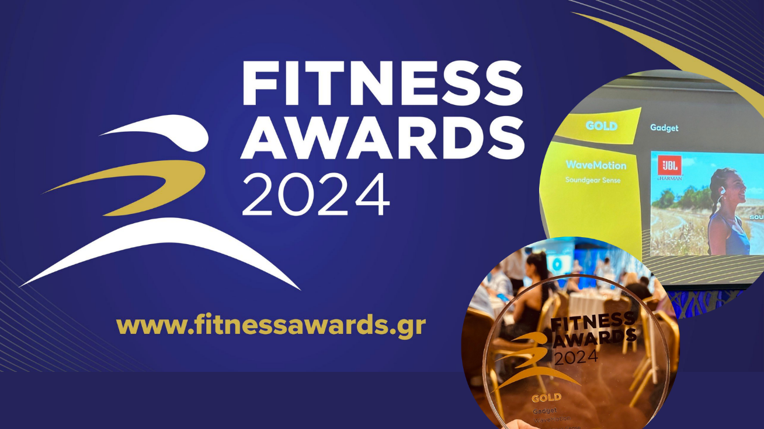

Athens – May 24, 2024. – WaveMotion S.A., Official Distributor for the Greek market, of great Audio & Vision Brands that hold leading positions in the Global Market, participated on Thursday, May 23, in the Fitness Awards Ceremony held at the Radisson Blu Park Hotel . For the 4th consecutive year, the Fitness Awards were organized in Greece by BOUSSIAS events, with the aim of highlighting and rewarding the important advances in the field of fitness, both at the level of services and professional spaces, as well as at the level of products, events, R&D, marketing and influencers.

WaveMotion S.A. participated in the Fitness Accessories category where we claimed the Gold award in Gadgets with our JBL Sport True Wireless Soundgear Sense headphones. JBL Soundgear Sense wireless headphones feature JBL OpenSound air transmission technology, which does not completely close your ear canal, offering you comfort so you can wear them for hours. Flexible ear hooks allow you to choose whether you want to concentrate on music or calls, or listen to the noises of the world around you. The detachable neckband provides even more security while you exercise, and the IP54 waterproof rating offers resistance to sweat or even light rain.

The JBL Soundgear Sense are distinguished by their ergonomics, robust features but above all, they bring the legendary sound of JBL to your sport. They are the ultimate accessory to accompany you on your fitness journey, be it running, aerobics, cycling, or any other physical activity. JBL becomes a companion in the fitness goals you want to achieve. JBL Soundgear Sense is as versatile as you are.

The awards ceremony was wonderful and we would like to express our sincere thanks to the judges, presenters and everyone involved in organizing the Fitness Awards for recognizing us in the field of fitness accessories and awarding this particular award.

More information can be found at

[Home | JBL (jblgreece.gr)](https://www.jblgreece.gr/)

and our social account [Facebook](https://www.facebook.com/JBLGreece) ,  [Instagram](https://www.instagram.com/jbl_greece/), [Tiktok](https://www.tiktok.com/@jbl_greece?lang=en)

**About WaveMotion S.A.**

WaveMotion, an importer and distributor, is seated in Athens Greece, operating on a wholesale basis, in the consumer electronics, telecommunications and computer industry for over 35 years. WaveMotion S.A. retains the official, exclusive, distribution for the Greek market of important Houses- in leading positions in the Global Arena, like JBL, harman/kardon, Cambridge Audio, Q Acoustics, QED, Goldring, rapoo, Native Union, Livall. Brand Development is the core skill of WaveMotion Team. The vision of our people is to expand WaveMotion’s Brands selection, following our tagline’s principles –Technology, Aesthetics, Design- and continue this journey of Ours, introducing compellingly and establishing decisively these Brands, in the eyes of our customers.

**About HARMAN**

HARMAN (harman.com) designs and engineers connected products and solutions for automakers, consumers, and enterprises worldwide, including connected car systems, audio and visual products, enterprise automation solutions; and services supporting the Internet of Things. With leading brands including AKG®, Harman Kardon®, Infinity®, JBL®, Lexicon®, Mark Levinson® and Revel®, HARMAN is admired by audiophiles, musicians and the entertainment venues where they perform around the world. More than 50 million automobiles on the road today are equipped with HARMAN audio and connected car systems. Our software services power billions of mobile devices and systems that are connected, integrated and secure across all platforms, from work and home to car and mobile. HARMAN has a workforce of approximately 30,000 people across the Americas, Europe, and Asia. In March 2017, HARMAN became a wholly owned subsidiary of Samsung Electronics Co., Ltd.