**For more information: Press release**

**JBL GREECE (Official Distributor WaveMotion Α.Ε )** For direct publication.

Τηλ.:210-9244505 Date.:30/04/2024

Email: jbl_greece@wavemotion.gr

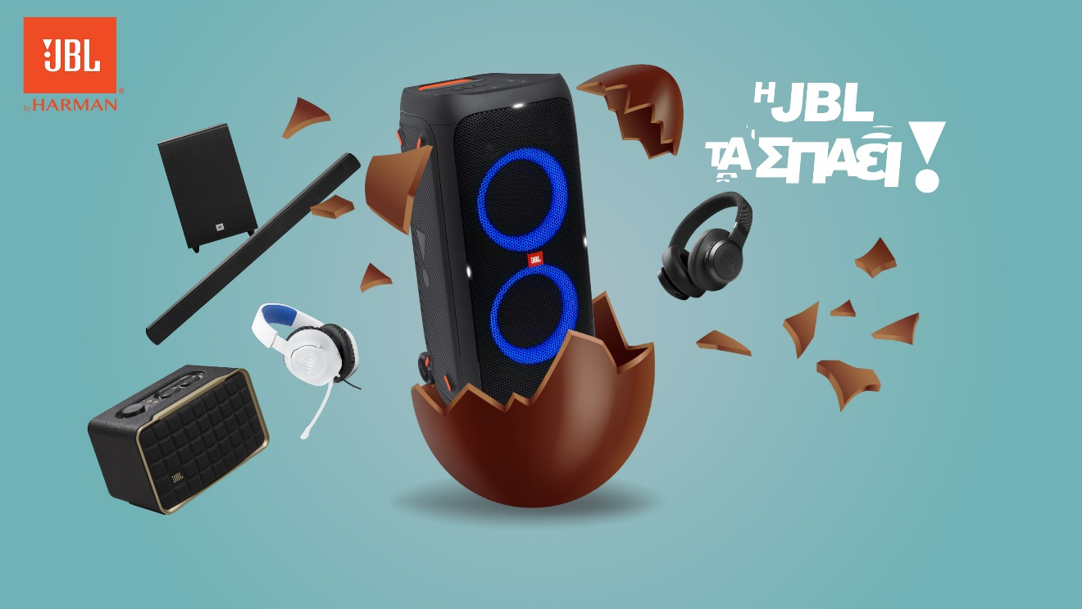

**This Easter, JBL rocks!**

Athens – 30 April 2024. – Easter is approaching, bringing along unforgettable family moments, spring outings, and big celebrations. What do they all have in common? The right music! Speakers, headphones, soundbars, or party boxes are here to accompany your Easter memories. The sounds of Easter, familiar to us all, become even more powerful. The music becomes even more uplifting. The sound is even more legendary. And this Easter, JBL is here and rocking it!

And of course, JBL is here for you, when you want to give the best gift. Whatever type your godchild is, JBL has the right product at prices that are literally unbeatable! Gamer or athlete? Fashion icon or tech geek? Outdoor enthusiast or TV lover? JBL's range of products will leave no godchild disappointed, and its Easter offers will leave no godparent stressed!

For this year's Easter season, the campaign 'JBL rocks it!' was created. Within the framework of the campaign, everyone's favorite chocolate Easter eggs are depicted, from which - also everyone's favorites - JBL products emerge. The campaign is based on the element of the chocolate egg reminiscent of Easter, within which beautiful surprises are hidden. As soon as the egg cracks, the surprise is revealed. At the same time, the message is used metaphorically to confirm the top offers that JBL has released for this year's Easter period. So, the eggs crack, and so do the prices!

**Happy Easter!**

Learn More to our social accounts [Facebook](https://www.facebook.com/JBLGreece) ,  [Instagram](https://www.instagram.com/jbl_greece/), [Tiktok](https://www.tiktok.com/@jbl_greece?lang=en)

**About WaveMotion**

WaveMotion, an importer and distributor, is seated in Athens Greece, operating on a wholesale basis, in the consumer electronics, telecommunications and computer industry for over 35 years. WaveMotion S.A. retains the official, exclusive, distribution for the Greek market of important Houses- in leading positions in the Global Arena, like JBL, harman/kardon, Q Acoustics, QED, Goldring, rapoo, Native Union, Livall. Brand Development is the core skill of WaveMotion Team. The vision of our people is to expand WaveMotion’s Brands selection, following our tagline’s principles –Technology, Aesthetics, Design- and continue this journey of Ours, introducing compellingly and establishing decisively these Brands, in the eyes of our customers.

**About VEESION (www.veesion.gr)**

The independent advertising company VEESION was created in 2020 during the lockdown. Open to challenges and collaborations, it is a creative partner to companies in Greece and the United Arab Emirates, offering integrated communication services: Advertising, Branding, Digital & social media, Brand Experience, Video Content, Guerrilla & Growth Hacking Marketing. VEESION constantly invests in talented people with exceptional character, in new technologies and in training. VEESION’s DNA consists of 4 main elements: Innovation, creativity, empathy and efficiency.

**About HARMAN**

HARMAN (harman.com) designs and engineers connected products and solutions for automakers, consumers, and enterprises worldwide, including connected car systems, audio and visual products, enterprise automation solutions; and services supporting the Internet of Things. With leading brands including AKG®, Harman Kardon®, Infinity®, JBL®, Lexicon®, Mark Levinson® and Revel®, HARMAN is admired by audiophiles, musicians and the entertainment venues where they perform around the world. More than 50 million automobiles on the road today are equipped with HARMAN audio and connected car systems. Our software services power billions of mobile devices and systems that are connected, integrated and secure across all platforms, from work and home to car and mobile. HARMAN has a workforce of approximately 30,000 people across the Americas, Europe, and Asia. In March 2017, HARMAN became a wholly owned subsidiary of Samsung Electronics Co., Ltd…