**For more information: Press Release**

**WaveMotion S.A** For direct publication

Τηλ.:210-9244505 Hμ.: 08/11/2023

Email: [Partners@WaveMotion.gr](mailto:Partners@WaveMotion.gr)

**Live the Sense of Marathon:**

**JBL Sport Headphones @ OPAP MARATHON EXPO 2023**

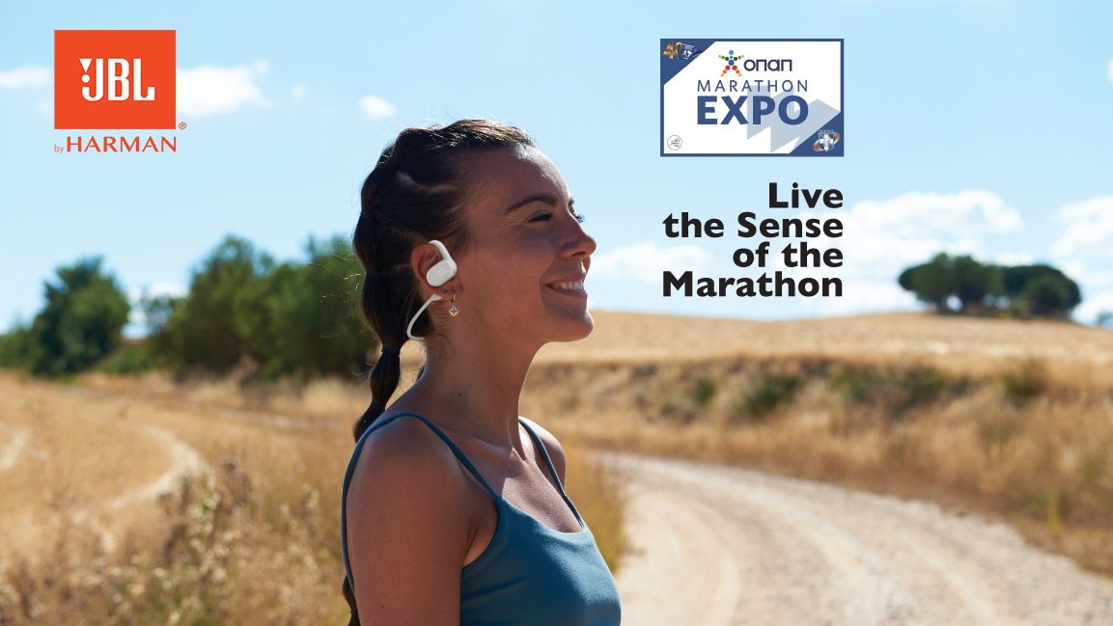

Athens, November 2023. – **WaveMotion** S.A official distributor of lifestyle offerings of JBL, will participate for one more year at OPAP MARATHON EXPO exhibition. The OPAP Marathon Expo, which is conducted parallel to the Athens Authentic Marathon is a unique sports and shopping festival, where participants and guests of the Marathon and all athletes can be informed and get acquainted with products and services in the sports industry. During the Show, Athletes and Guests will be presented with the new, updated range of JBL Sport Headphones. JBL Sport Headphones are ergonomic, comfortable to wear but most of all, they deliver the legendary JBL Sound. Wired or Wireless, with reflect and unrivaled flexibility, sweatproof cables and heart rate monitor, choose your own model out of a great range.

**JBL** will present for first time its first-ever true wireless open-ear earbuds,JBL Soundgear Sense. Featuring JBL OpenSound Technology with air conduction, the new earbuds transform the listening experience and set a new standard for audio quality in this form factor. You will also have the chance to discover JBL Endurance Series & Reflect Aero. At OPAP MARATHON EXPO exhibition you can visit **JBL’s** kiosk to try them for the very first time!

**JBL Soundgear Sense**

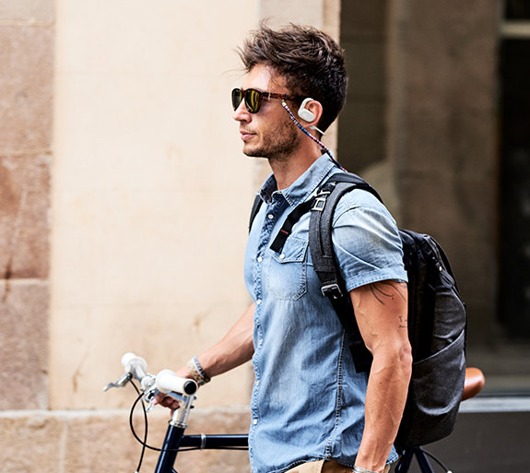True wireless open-ear headphones feature JBL OpenSound Technology with air conduction, which doesn’t completely close off your ear canal, making them comfortable enough to wear for hours. Flexible earhooks rotate, so you can choose whether you want to focus on your music or calls, or let in more sound from the world around you. A detachable neckband provides an even more secure fit while you’re working out, and an IP54 rating means that they can stand up to sweat—or even a light rainfall. Your voice will be crystal clear, even on a windy day, thanks to four voice mics. Customize how you use the intuitive touch controls on each earbud to handle your music and calls with the My JBL Headphones app. JBL Soundgear Sense is as adaptable as you are.

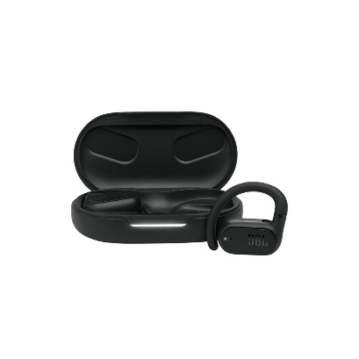

* JBL OpenSound Technology
* Enhanced Dynamic Sound
* Up to 24 hours of battery life, plus speed charge
* Splash and dust resistant
* Dual connect and sync with fast pair
* 4 mics for crisp, clear calls
* All access touch control
* My JBL Headphones app

**JBL Reflect Aero**

Designed with POWERFINS for a secure fit and better-fitting Oval Tubes™ for all-day comfort, **JBL Reflect Aero** earbuds are the perfect companions for your active lifestyle. Stay focused on your goals with True Adaptive Noise Cancelling, while Smart Ambient technology keeps you alert to your surroundings. Whether you’re out for a light walk or into a serious workout, the fast-charging 24-hour battery capacity means you’ll never miss a beat of your personal soundtrack, powered by rich JBL Signature Sound. And when it’s time to talk, 3 mics on each IP68 dustproof and waterproof earbud help to ensure perfect calls, wherever your journey leads.

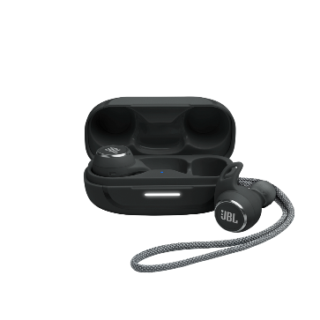**Features:**

* JBL Signature Sound
* True Adaptive Noise Cancelling with Smart Ambient
* 4 mics for zero noise
* 8+16 hours of fast-charging battery life
* Extreme dustproof and waterproof
* Comfortable, secure fit

**JBL Endurance Race**

**JBL Endurance Race True Wireless Active earbuds** are always geared up and ready to go. With 30 hours of battery life and a waterproof, dustproof design, they keep you rocking with JBL Pure Bass and all-day comfort. The sturdy, superior fit lets you stay active from the beach to the boardroom with better sealing and stability. Get help from your preferred voice assistant, manage your audio, and make perfect calls with the touch of a button. Or, when you need to hear your surroundings, tune into the world around you with enhanced ambient sound.

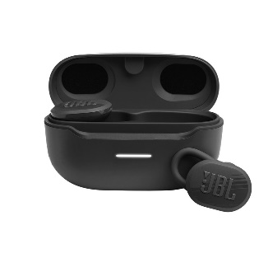

**Features:**

* Up to 30 hours of battery life
* IP67 Waterproof and Dustproof
* Ambient Aware & TalkThru
* Enjoy perfect calls and your preferred VA
* JBL Headphones App

**JBL Endurance Run 2 and Endurance Run 2 BT**

Results matter and when you have the perfect headphones there’s nothing standing in between you and your workout. Streaming wirelessly, the **JBL Endurance Run 2 and Endurance Run 2 BT** wireless will get you the motivation you need to push harder with powerful JBL sound. With their FlipHook™ design, they adapt to an in-ear or behind-the-ear fit for added convenience. A comfortable combination of FlexSoft™ ear tips and TwistLock™ technology means these buds are guaranteed never to hurt or fall out. Thanks to IPX5 waterproof, JBL Endurance Run 2 wireless headphones keep up with your every step so sweat or rain will not ruin your workout. With a playback of 10 hours, the JBL Endurance Run 2 wireless feature an in-line microphone and remote for hands-free control of sound and calls. The magnetic buds secure your JBL Endurance Run 2 wireless conveniently around your neck while not in use. Enjoy your workout!

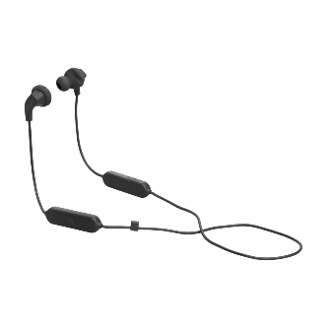

**Endurance RUN BT 2**

**Features:**

* FlipHook™
* Waterproof
* Hands-free calls
* Magnetic Buds

**Endurance RUN 2**

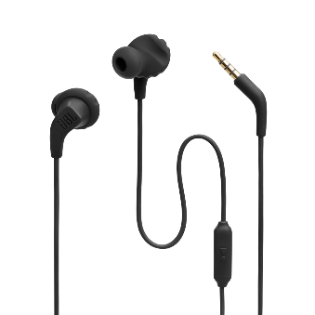**Features:**

* FlipHook™
* Sweatproof
* Up to 10 hours of batter life
* Hands-free calls
* Magnetic Buds
* JBL Pure Bass Sound
* Wireless connection through Bluetooth

**Endurance Peak 3**

Your lifestyle is active—you need wireless earbuds that can keep up. The **Endurance Peak 3** is the perfect training partner, pumping your motivational playlists to you with up to 50 hours of playback and rich JBL Pure Bass Sound you can feel in your muscles. The durable IP68 dust and waterproof design can handle the dustiest mountain trail and the sweatiest gym session, while the bendable Powerhook™ together with the TwistLock™ ear hook enhancer ensures a secure, comfortable fit that stays in no matter how you move your body. And with the ability to make crystal clear calls from anywhere and stay aware of your surroundings, you’ll stay connected to the world no matter where your workout takes you.

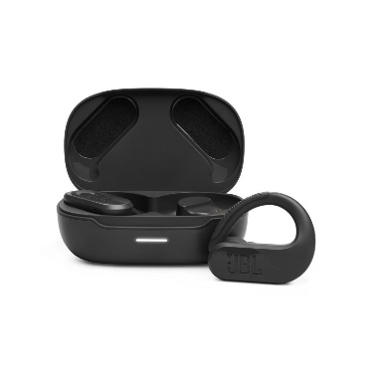**Features:**

* JBL Pure Bass Sound
* Up to 50 total hours of playback with speed charge
* IP68 dust and water proof
* Ambient Aware & Talk Thru
* 4-Mic Crisp, Clear Calls
* Powerhook™ design for an ergonomic fit
* JBL Headphones App

**Pricing and Availability**

JBL Sport Headphones are available now in selected Retailers and Authorized Resellers from 32,95€ up to 169,00€. More information here:<https://www.jblgreece.gr/product-category/sport-headphones-el>

***Follow us on Social:***

Instagram: @jbl_greece

Facebook: JBL Greece

Tiktok: jbl_greece

**About WaveMotion**

WaveMotion, an importer and distributor, is seated in Athens Greece, operating on a wholesale basis, in the consumer electronics, telecommunications and computer industry for over 35 years. WaveMotion S.A. retains the official, exclusive, distribution for the Greek market of important Houses- in leading positions in the Global Arena, like JBL, harman/kardon,  KEF, Q Acoustics, QED, Goldring, rapoo, Native Union,XGIMI & Livall . Brand Development is the core skill of WaveMotion Team. The vision of our people is to expand WaveMotion’s Brands selection, following our tagline’s principles –Technology, Aesthetics, Design- and continue this journey of Ours, introducing compellingly and establishing decisively these Brands, in the eyes of our customers.

**About HARMAN**

HARMAN (harman.com) designs and engineers connected products and solutions for automakers, consumers, and enterprises worldwide, including connected car systems, audio and visual products, enterprise automation solutions; and services supporting the Internet of Things.  With leading brands including AKG®, Harman Kardon®, Infinity®, JBL®, Lexicon®, Mark Levinson® and Revel®, HARMAN is admired by audiophiles, musicians and the entertainment venues where they perform around the world. More than 50 million automobiles on the road today are equipped with HARMAN audio and connected car systems. Our software services power billions of mobile devices and systems that are connected, integrated and secure across all platforms, from work and home to car and mobile. HARMAN has a workforce of approximately 30,000 people across the Americas, Europe, and Asia. In March 2017, HARMAN became a wholly owned subsidiary of Samsung Electronics Co., Ltd…