PRESS RELEASE
27 Οκτωβρίου 2023
GET YOUR TECH FASHION FIX WITH THE NEW NATIVE UNION LAUNCHES
When technology meets unparalleled minimal style
Native Union, the innovative brand that seamlessly marries fashion and technology, is excited to present its latest collection - a harmonious fusion of sustainability, style and functionality. These groundbreaking releases are poised to revolutionise the way we interact with our tech accessories, adding a touch of elegance to every aspect of our modern digital lifestyle.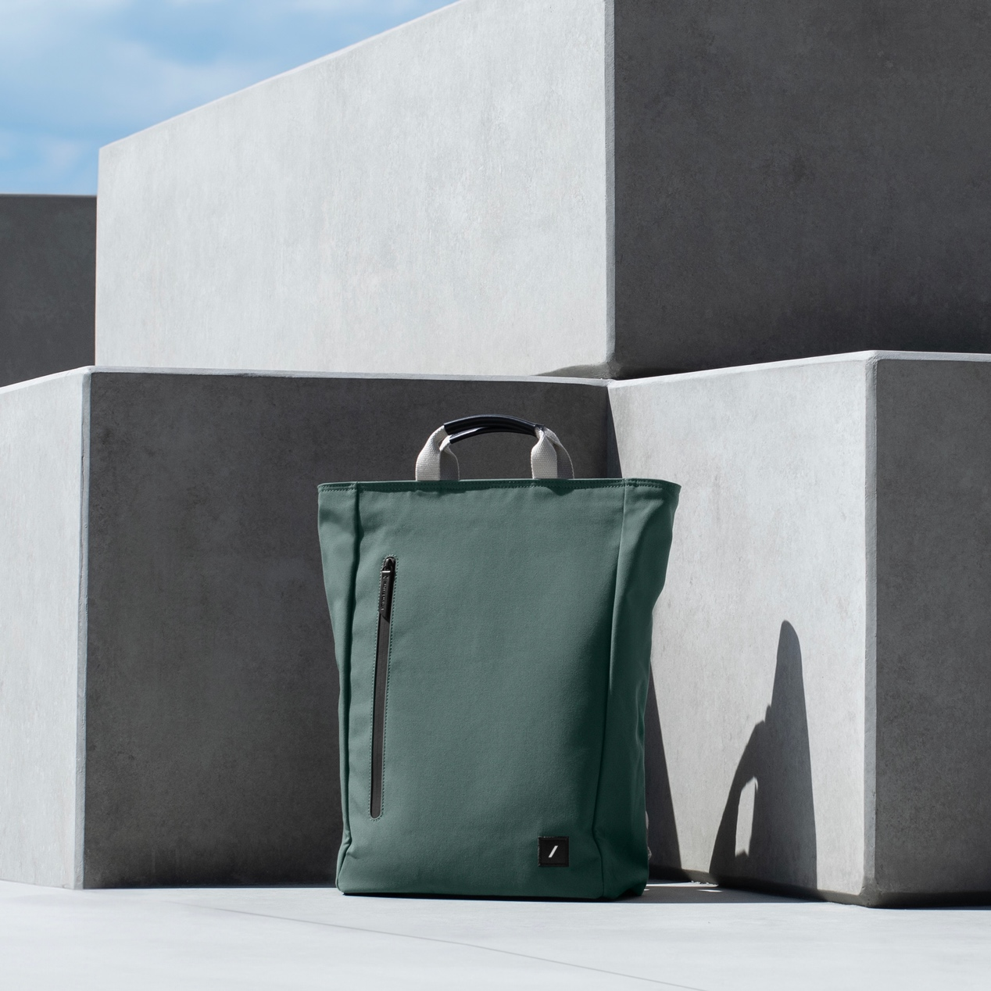 Native Union Backbag: your ecological daily companion
More than just an everyday bag, the Native Union Backbag is a bold statement of sustainability and contemporary elegance. Its modern, minimalist profile conceals a 20-litre interior designed to suit your every need. Made from 100% recycled polyester (rPET) derived from plastic bottles, this bag is an eco warrior's dream and proof of Native Union's commitment to the environment.
Inside, one finds a technological marvel with a padded laptop case that accommodates devices up to 16". Mesh pockets accommodate cables, chargers and other essentials, while a key strap, water bottle holder and discreet hidden pocket add an extra layer of convenience. The Backbag is built to last, featuring a waterproof finish, reinforced stitching, YKK zippers and military-grade Cordura fabric where it matters most. Thick organic cotton straps ensure comfort when using the backpack, while the sturdy top handle provides tote-style versatility. And for travelers, the luggage strap doubles as a stylish solution for storing your straps during travel.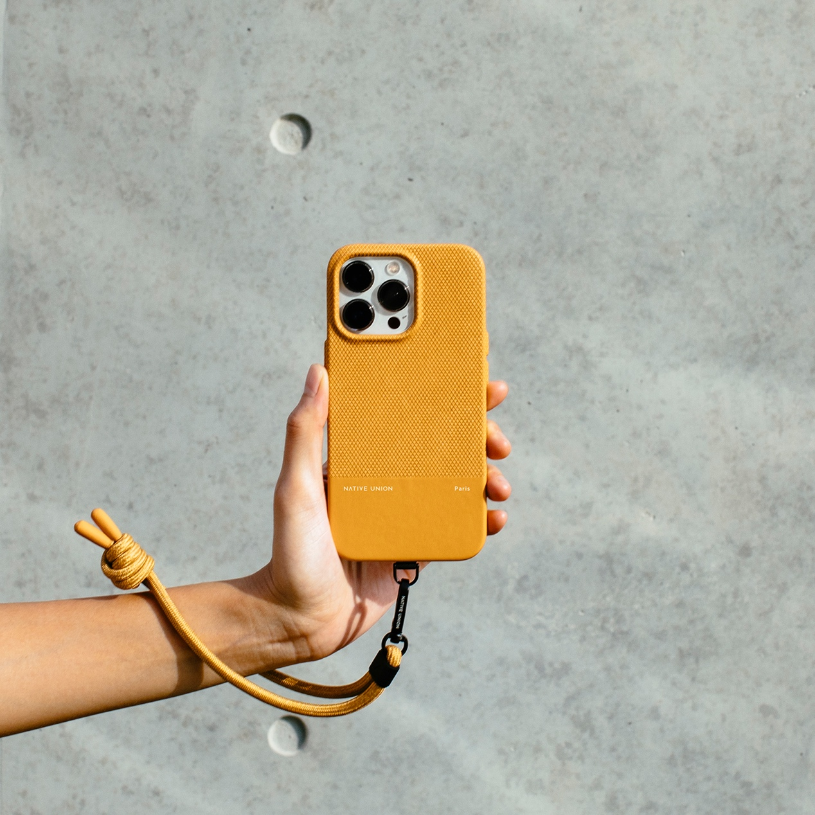iPhone 15 Series Cases: Style meets durability
Enjoy the elegance of texture for your iPhone with Native Union's iPhone 15 series cases. These cases redefine style and sustainability while providing exceptional protection for your device. Made with Yatay™ by Coronet, a premium plant-based material from Italy, these cases are both eco-friendly and luxurious. The timeless contrast of smooth and crisscrossed leather is reimagined in a fully wrapped design for a raised finish.
These cases offer carefree transportation with drop protection up to 1.8 metres (6ft), thanks to their robust construction. And, of course, they're fully compatible with MagSafe charging and accessories, ensuring a seamless experience for tech enthusiasts.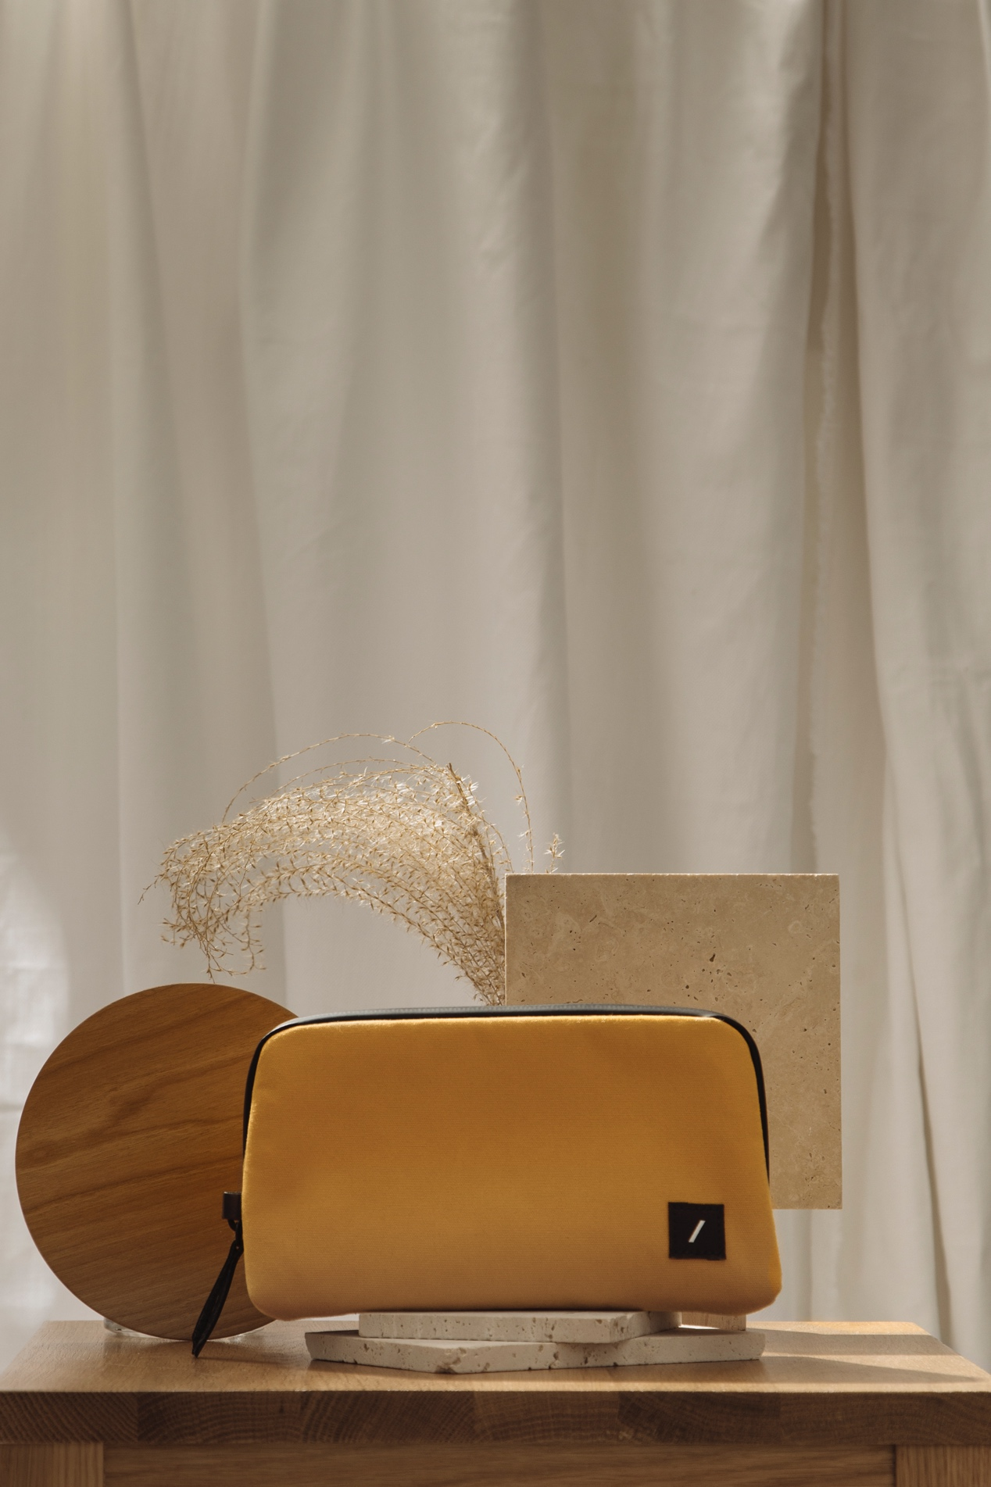Stow Organizer: Unleash the power of organisation
Embrace a clutter-free life with Native Union's Stow Organizer, a lightweight solution for your growing collection of tech essentials. But it's not just about order, it's also about sustainability. Made from 100% recycled polyester (rPET) coated for a water-repellent finish, this organizer embodies care for the environment. Leather accents made from recycled materials and zippers made from 100% recycled nylon underscore Native Union's commitment to thoughtful design and eco-consciousness. With versatile pockets designed to accommodate all your accessories, the Stow Organizer brings order to chaos.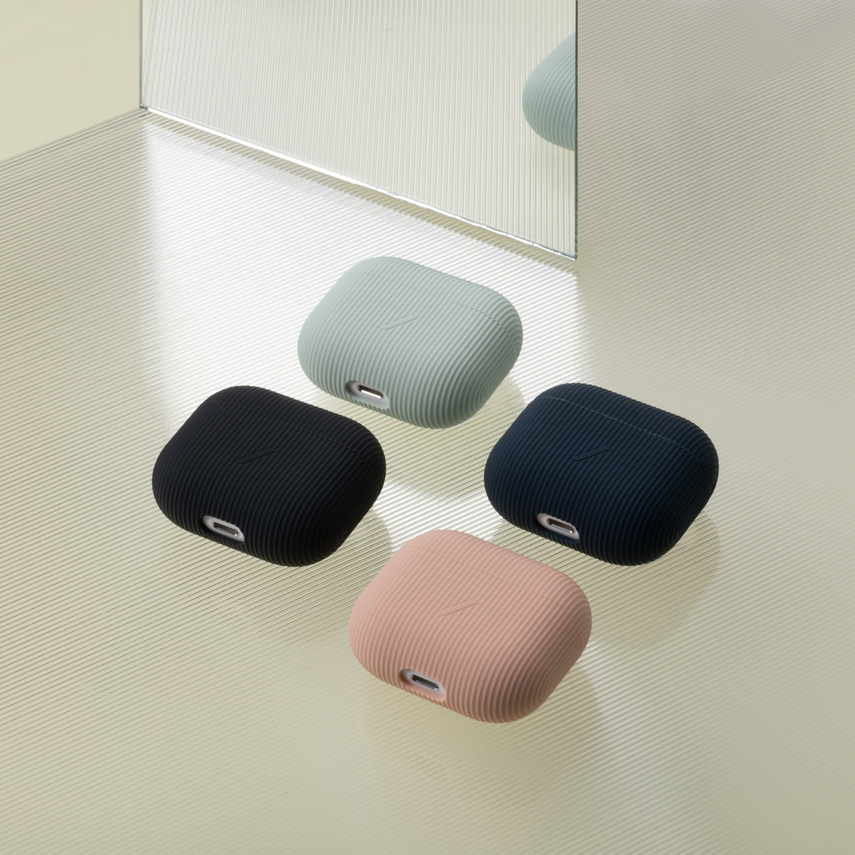Curve Cases for AirPods (3rd Generation): Elevate your style
Upgrade your AirPods (3rd generation) with Native Union's Curve cases. Contemporary design meets style with cleaner striped finishes and a range of charming pastel colours. Made from smooth silicone, these cases offer protection that is as good to the touch as it is to the eye. Enjoy hassle-free access to your AirPods, charging port and controls while making a fashion statement.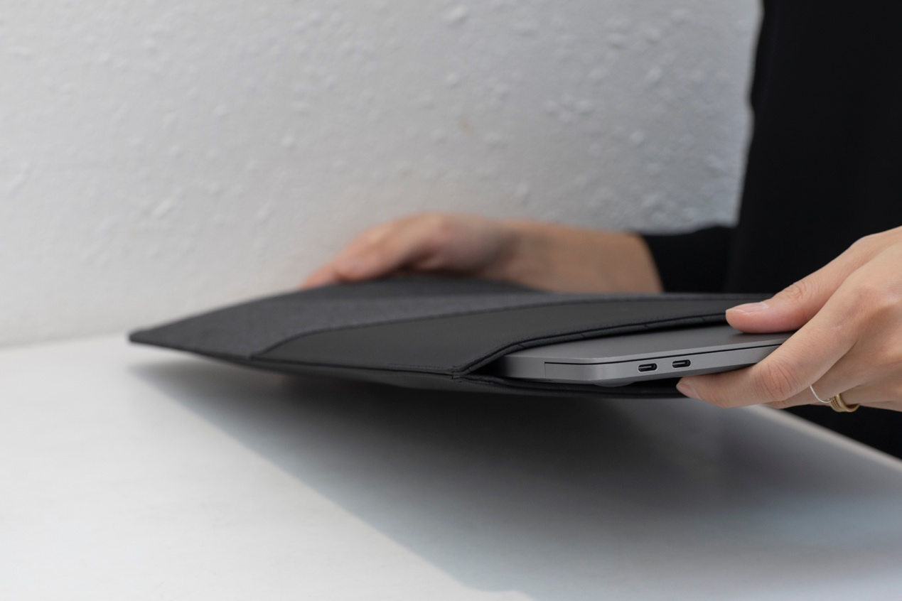MacBook Case: Sleek and Sustainable Protection
The Native Union MacBook case is a testament to elegance and environmental friendliness. Designed for a 15" MacBook Pro, this case is made from recycled canvas produced exclusively from plastic bottles. The result? A sleek, slim case that provides everyday protection without compromise. The coated canvas finish adds an extra layer of care, while the easy magnetic closure ensures quick access to your device and essentials.
Native Union continues to redefine fashion in technology, seamlessly bridging style, functionality and sustainability. With a firm commitment to minimizing their environmental footprint, Native Union invites you to explore the next generation of tech accessories.
##
About NATIVE UNION
The company’s history essentially begins with the release of the first iPhone in 2007. This event inspired CEO and co-founder, Igor Duc, to start NATIVE UNION. He knew it would change the way we live. Its first product, the Pop Phone Retro Handset, was designed for a more tangible and easy experience when making calls. Over a decade and many gadgets later, she now has offices in Los Angeles, Hong Kong, Paris and a presence in every corner of the globe. In Greece it is represented by WaveMotion and through them it is distributed to a wide network of resellers (major technology chains, premium retailers and e-shops).
About WaveMotion
WaveMotion is an Athens-based technology importing company, based in Athens, Greece, active in the field of smart electronics, audio and video. “WaveMotion” refers to words such as: sound, light, image, power, speed, fun and suggests that as waves move constantly and with speed, so does technology in sound, image, telecommunications and IT. WaveMotion’s mission is to provide High Technology products that combine Cutting Edge Technology with Aesthetics and Modern Design. Today, WaveMotion officially distributes in the Greek market international brands that hold leading positions in their field such as harman/kardon, JBL, Kef, Q Acoustics, Audio Pro, QED, Goldring, rapoo, Livall and Native Union.

Learn more at www.wavemotion.gr, https://www.wavemotion.gr/our-brands/native-union
and the company's Social Media
Facebook
https://www.facebook.com/people/WaveMotion-Technology/100076063659286/
Linkedin
https://www.linkedin.com/company/wavemotion/

