**For more information: Press release**

**WaveMotion S.A** For direct publication.

t.:210-9244505 Hμ.: 28/06/2022

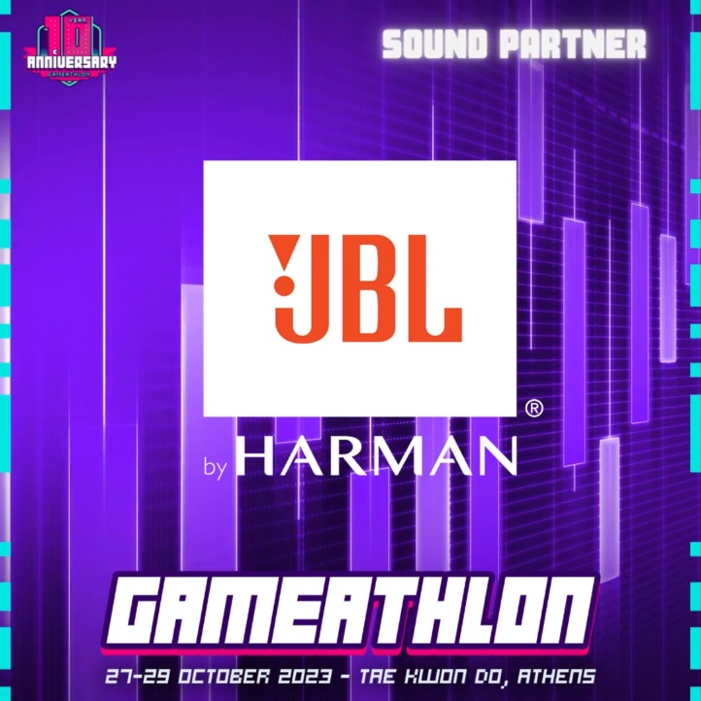Email: jbl_greece@wavemotion.gr

**JBL is the Sound Partner**

**of the biggest Gaming Event for a second year!**

**GAMEATHLON, the biggest Gaming Event of Greece celebrates 10 years and JBL could not miss it!**

Αthens – 26 October 2023.- WaveMotion SA, Official Distributor of JBL lifestyle audio products for Greece, announces JBL’s collaboration as Sound Partner with the biggest gaming event of Greece- GAMEATHLON.

GAMEATHLON opens its doors once again in Friday 27th 2023 and sets its Gaming arena at Faliro Olympic Hall (Tae Kwon Do Hall). For its 10th  Year Celebration, GAMEATHLON is getting ready to host thousands of visitors to this mega event, with gaming at its core. At the event you will meet professional gamers, ministers, cosplayers, programmers, tattoo artists, communities, multinational executives, professors, musicians and the most notorious content creators... all in the same technological blockbuster with the purest atmosphere!

JBL brings its premium Gaming sound and sets the beat as Sound Partner of this important gaming event. In an immersive booth, designed exclusively for the event, JBL will present its Quantum gaming range created for Gamers who enjoy challenges, unmatchable battles, and contests during this unique happening.

JBL brings its premium Gaming sound and sets the pace to GAMEATHLON 2023, as its Sound Partner. The JBL Quantum series will be in the center of the stage, with the JBL Quantum 400 offering the most realistic sound experience to those who will have the opportunity to be at the Big Stage. For those Gamers who enjoy challenges and being on the Small stage or the PC Arena, the Quantum series will turn every game into an epic event.

**JBL Quantum** gaming range includes 16 different gaming Headsets (wired, Bluetooth & wireless), two **TWS headphones (Quantum TWS & Quantum TWS Air) and the USB Microphone (Quantum Stream).**

The **JBL Quantum** range is engineered for the most realistic sound experience ever in a gaming headset. Amplifying every audible detail with pinpoint accuracy and immersive sound for a true competitive advantage, thanks **to JBL QuantumSOUND Signature™.**

From the thrill of tracking enemies in FPS games, to engaging in epic MOBA battles, **the JBL Quantum** range brings game-winning audio.

The flagship **JBL Quantum ONE** takes sound to the next level, built exclusively with JBL’s own QuantumSPHERE 360™ sound tech. Extensively tested with gamers around the world, the head tracker sensors and spatial audio will precisely locate and pair visual objects with their sound.

Follow us to our social accounts [Facebook](https://www.facebook.com/JBLGreece) & [Instagram](https://www.instagram.com/jbl_greece/)

**GameAthlon 2023** – Tae Kwon Do

Friday 27, 17.00-22.00

Saturday 28, 10.00-22.00

Sunday 29, 10.00-22.00

**About WaveMotion**

WaveMotion, an importer and distributor, is seated in Athens Greece, operating on a wholesale basis, in the consumer electronics, telecommunications and computer industry for over 35 years. WaveMotion S.A. retains the official, exclusive, distribution for the Greek market of important Houses- in leading positions in the Global Sound Arena like JBL, harman/kardon, Audio, Kef, Q Acoustics, Audio Pro, QED and Goldring. Newly formed Lifestyle Technology acquired official distribution for rapoo, Livall, Native Union. Brand Development is the core skill of WaveMotion Team. The vision of our people is to expand WaveMotion’s Brands selection, following our tagline’s principles –Technology, Aesthetics, Design- and continue this journey of Ours, introducing compellingly and establishing decisively these Brands, in the eyes of our customers.

**About HARMAN**

HARMAN (harman.com) designs and engineers connected products and solutions for automakers, consumers, and enterprises worldwide, including connected car systems, audio and visual products, enterprise automation solutions; and services supporting the Internet of Things. With leading brands including AKG®, Harman Kardon®, Infinity®, JBL®, Lexicon®, Mark Levinson® and Revel®, HARMAN is admired by audiophiles, musicians and the entertainment venues where they perform around the world. More than 50 million automobiles on the road today are equipped with HARMAN audio and connected car systems. Our software services power billions of mobile devices and systems that are connected, integrated and secure across all platforms, from work and home to car and mobile. HARMAN has a workforce of approximately 30,000 people across the Americas, Europe, and Asia. In March 2017, HARMAN became a wholly-owned subsidiary of Samsung Electronics Co., Ltd.