PRESS RELEASE

27 Οκτωβρίου 2023

**BACK TO THE CITY: HOW TO ORGANISE YOUR OFFICE WITH THE HELP OF NATIVE UNION**

*For a dynamic return to reality that will help you achieve your goals for the new season*

As the pace of the city gradually picks up and workplaces come alive again, Native Union is here to set us straight by organizing the office of gadget lovers everywhere. Minimal design and revolutionary tech solutions make up a sustainable collection of products designed to modernize our daily lives.

Which products stand out this season and promise to transform our office into a paradise of efficiency and elegance?

[**Native Union fast Gan Charger PD 35W**](https://www.wavemotion.gr/el/shop/new-arrivals-2-el/fast-gan-charger-pd-35w-black)

Power meets style - it's the smallest and lightest charger, featuring innovative GaN technology. This small and compact device with dual-port Power Delivery takes on the task of charging laptops, tablets and smartphones simultaneously, delivering guaranteed performance, reaching 50% of the total charge in just 30 minutes.

[**Native Union Snap 2-in-1 Wireless Charger**](https://www.wavemotion.gr/el/shop/new-arrivals-2-el/snap-2-in-1-wireless-charger-iphone-qi-enabled-2m-cable)

Designed for multi-tasking enthusiasts, this 2-in-1 Snap Wireless Charger combines MagSafe and Qi technology for simultaneous, convenient use, and pairs perfectly with the Fast Gan Charger. The adjustable angle of the device allows the user to watch videos or engage in video calling while charging their iPhone without hesitation, while the perfectly minimalist design allows us to organize our space without annoying cords! The Snap 2-in-1 Wireless Charger, finally, is enriched with two distinctive LED indicators to show the charging status.

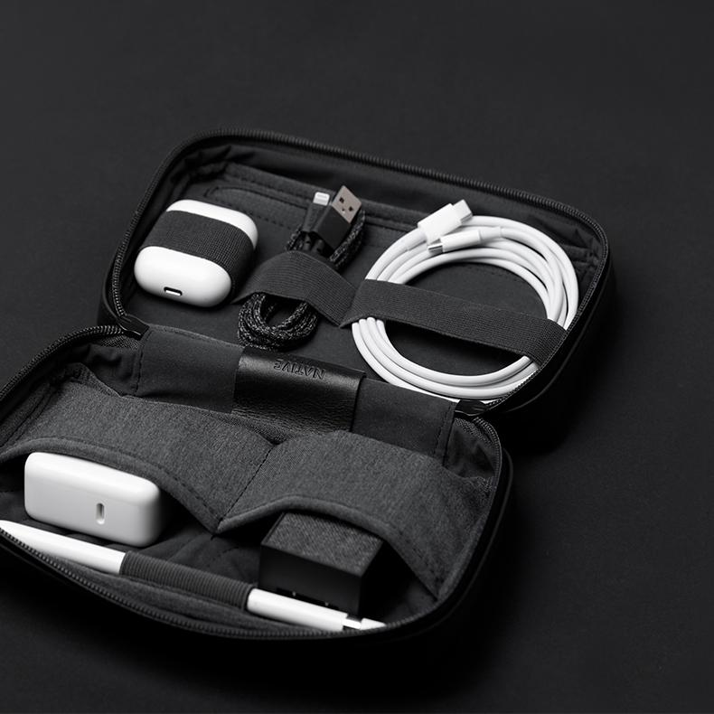

[**Native Union Stow Organizer Pouch with Fabric**](https://www.wavemotion.gr/el/shop/technology-accessories-el/stow-organizer-pouch-with-fabric)

Where do all the cables and micro gadgets go when we travel or go to important meetings? But of course inside the very popular Stow Organizer! Made with high quality fabric and meticulous attention to detail, the Stow Organizer adds a touch of elegance to the workplace.

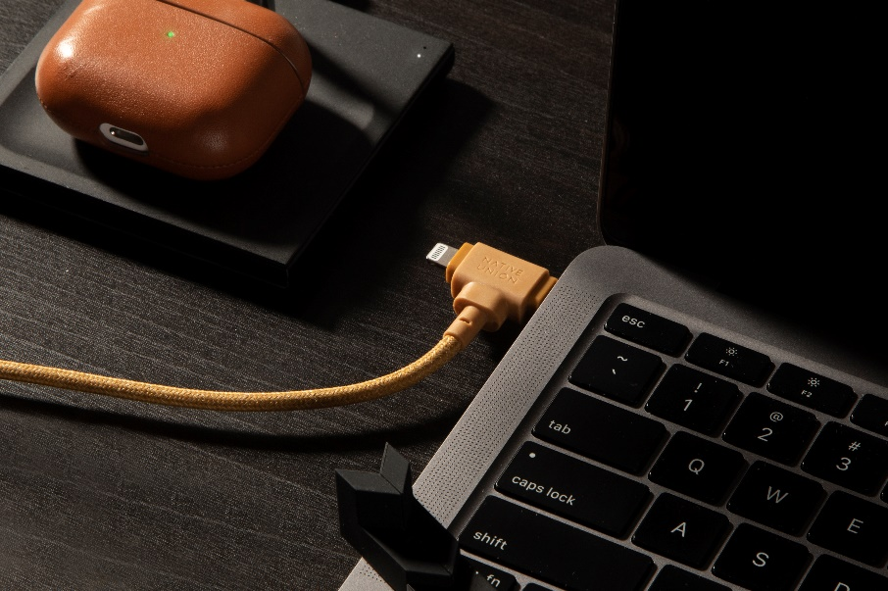[**Native Union Belt Cable Duo 2in1**](https://www.wavemotion.gr/el/shop/technology-accessories-el/cables-el/belt-cable-duo-2in1-usb-c-to-usb-c-lighting-1-5m)

The ultimate charging cable at our fingertips - one that covers every charging need, fast, sustainable, universal. Designed for greater convenience and flexibility, it features two ports for parallel charging. It is a highly essential gadget for any lifestyle as it is built to the highest standards of durability, and comes with a lifetime warranty and is MFi certified.

Whatever your needs are, Native Union is sure to fulfill them successfully, following the strictest sustainability protocols!

##

**About NATIVE UNION**

The company’s history essentially begins with the release of the first iPhone in 2007. This event inspired CEO and co-founder, Igor Duc, to start NATIVE UNION. He knew it would change the way we live. Its first product, the Pop Phone Retro Handset, was designed for a more tangible and easy experience when making calls. Over a decade and many gadgets later, she now has offices in Los Angeles, Hong Kong, Paris and a presence in every corner of the globe. In Greece it is represented by WaveMotion and through them it is distributed to a wide network of resellers (major technology chains, premium retailers and e-shops).

**About WaveMotion**

WaveMotion is an Athens-based technology importing company, based in Athens, Greece, active in the field of smart electronics, audio and video. “WaveMotion” refers to words such as: sound, light, image, power, speed, fun and suggests that as waves move constantly and with speed, so does technology in sound, image, telecommunications and IT. WaveMotion’s mission is to provide High Technology products that combine Cutting Edge Technology with Aesthetics and Modern Design. Today, WaveMotion officially distributes in the Greek market international brands that hold leading positions in their field such as harman/kardon, JBL, Kef, Q Acoustics, Audio Pro, QED, Goldring, rapoo, Livall and Native Union.

Learn more at [www.wavemotion.gr](http://www.wavemotion.gr), <https://www.wavemotion.gr/our-brands/native-union>  
and the company's Social Media

**Facebook**<https://www.facebook.com/people/WaveMotion-Technology/100076063659286/>   
  
**Linkedin**<https://www.linkedin.com/company/wavemotion/>