PRESS RELEASE
27 Οκτωβρίου 2023
HARMAN KARDON LAUNCHES IN GREECE 3 NEW BLUETOOTH SPEAKERS THAT ELEVATE THE AUDIO EXPERIENCE
Harman/Kardon's new Bluetooth speakers, Aura Studio 4, Go + Play 3 and Luna change the listening experience, further enhancing sound quality while focusing on the innovation of design that suits it every time.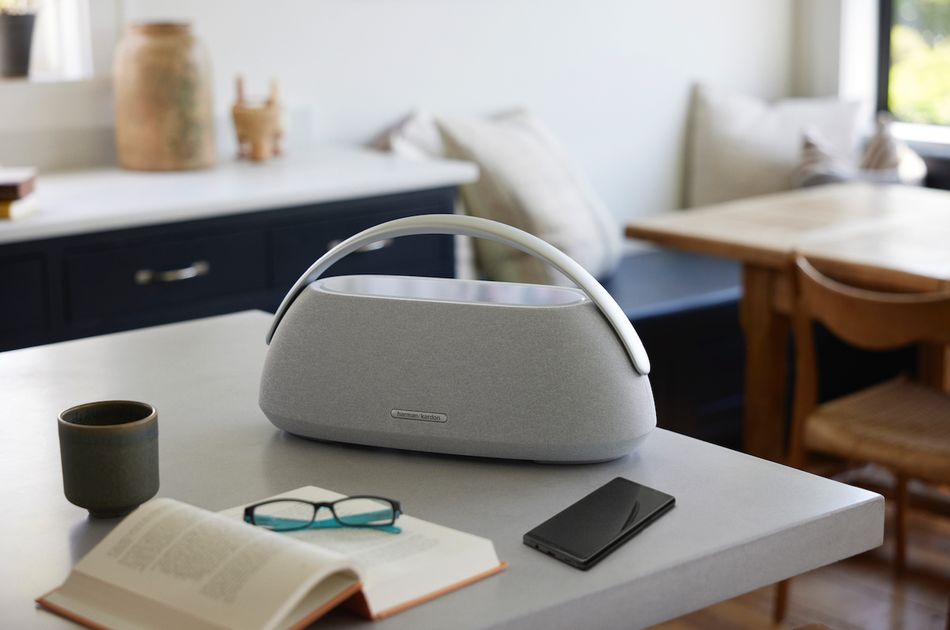
Symbols of innovation, innovation and design, the three new Harman/Kardon products are a natural evolution for a brand that is constantly progressing, while at the same time they constitute a visual intervention in space, upgrading and inspiring the everyday environment. Three speakers that transform our microcosm and make us hear more, differently - as never before - and experience, but also share, emotions and experiences.
The Harman/Kardon Luna is a premium portable Bluetooth speaker that stands out for its high-quality sound, combined with its minimalist silhouette. Thanks to its advanced 2-way speaker system and built-in software, it ensures exceptional sound clarity, offering 12 hours of continuous music enjoyment. Solidly constructed with a premium fabric and anodised aluminium top casing, waterproof and dust-resistant, it is also a contemporary style statement.
The highly anticipated Harman/Kardon Aura Studio 4 combines exceptional sound with immersive design, a symbol of intelligent design and performance that turns the audio experience into an art form and celebrates the multisensory experience. The 5.2" inch subwoofer and 6-speaker array guarantee an unparalleled listening experience, while the 324 crystals at the base of the dome synchronize with the music and produce color in five different patterns - depending on your mood! Made largely from recycled materials, it is also a statement of sustainability inspired by Nature.
The Harman/Kardon Go + Play 3 returns redesigned inside and out, while retaining its distinctive semi-circular silhouette. The speaker boasts powerful, dynamic sound that fills the room thanks to its 3-way high-performance speaker system, including a new subwoofer whose loudspeaker is directional ("facing") down to fill your room with bass. With a battery life of up to 8 hours, it can be moved anywhere thanks to the ergonomic anodized aluminum handle.
Harman Kardon Aura Studio 4, Go + Play 3 and Luna will soon be available at select retail networks and an extensive network of Harman Kardon Authorized Resellers nationwide. Their suggested retail price is €349, €369 and €189 respectively.
More information about the new Harman Kardon Bluetooth speakers at www.wavemotion.gr/our-brands/harmankardon, and on the social accounts:
Facebook: https://www.facebook.com/harmankardongreece
Instagram: Harman Kardon Greece & Cyprus (@harmankardongreece) - Instagram photos and videos
Linkedin: www.linkedin.com/company/wavemotion
##
About HARMAN KARDON
Harman Kardon creates beautiful sound that speaks to you. The world-renowned audio brand seamlessly blends function and form through the highest sound quality, elegant design and meticulous attention to detail. In 1954, Harman Kardon became the first audio brand to release a compact AM/FM Hi-Fi receiver. For over 65 years, Harman Kardon has been a leading expert in audio engineering and design, capturing ears and hearts. Affirming the brand's design position, the iconic Harman Kardon SoundSticks are part of the permanent collection of the Museum of Modern Art in New York City.

About WaveMotion
WaveMotion is an Athens-based technology importing company, based in Athens, Greece, active in the field of smart electronics, audio and video. "WaveMotion" refers to words such as: sound, light, image, power, speed, fun and suggests that as waves move constantly and with speed, so does technology in sound, image, telecommunications and IT. WaveMotion's mission is to provide High Technology products that combine Cutting Edge Technology with Aesthetics and Modern Design. Today, WaveMotion officially distributes in the Greek market international brands that hold leading positions in their field such as harman/kardon, JBL, Kef, Q Acoustics, Audio Pro, QED, Goldring, rapoo, Livall and Native Union.
Learn more at www.wavemotion.gr, at https://www.wavemotion.gr/our-brands/harmankardon
and the company’s Social Media
Facebook
https://www.facebook.com/people/WaveMotion-Technology/100076063659286/
Linkedin
https://www.linkedin.com/company/wavemotion/

