**For more information: Press Release**

**JBL GREECE** (OFFICIAL DISTRIBUTOR WAVEMOTION S.A ) For direct publication

Tηλ.:210-9244505 Date.: 29/08/2023

**Believe in yourself – Start now!**

Athens – 29 August 2023. WaveMotion S.A, Official Distributor of JBL lifestyle audio products for Greece, presents its new campaign «Believe in yourself – Start now!» With the return from summer vacation, we line up for new beginnings. Are you getting ready for the Fall, the school or the university? Are you thinking about a new hobby, a new sport? JBL will be the best company.

Through this inspiring campaign, JBL motivates you to believe in yourself and start doing what you really want, what you have been putting off until now or what you've been afraid to start. In the adventure of success and the goals you have set, JBL is there and inspirit you in your every dream and suggest you the ideal product for every new beginning.

JBL will be your company to this trip of achieving your goals! If you want to spend time with your family, enjoying movies and music nights, JBL speakers and soundbars with legendary sound will help you to catch this feeling. If you decide to start exercising and elevate your training ,JBL waterproof sport headphones will give you the opportunity to achieve your goal even on the rainiest day. If your goal is to discover the world and organise the long-awaited trip that has always been in your mind but you always postpone it, just do it with your JBL product.

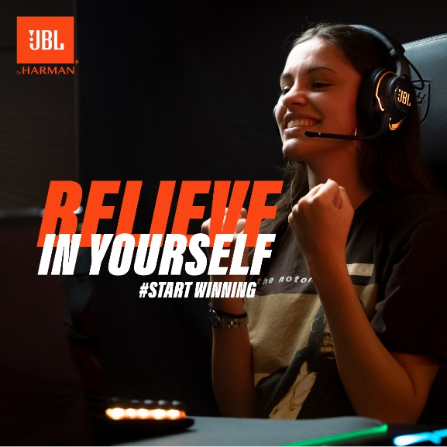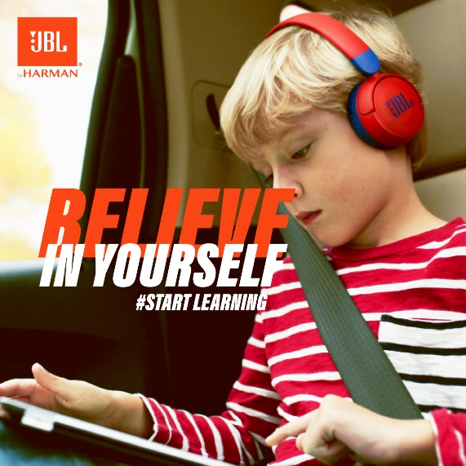

The campaign is based on storytelling. It includes stories which presents JBL products alongside people who try to achieve their goal. Each story presents a different goal, since the purpose of the campaign is to highlight as many goals as possible for as many people as possible. So the tittle of every creative is different: Start Running, Start Exploring, Start Growing, Start Travelling, etc. The main message of this campaign, «Believe in yourself» remains the same. In this campaign will also participate in, people who started, tried and finally succeed their goals. They will tell us their success story, how they manage to reach their own top and they will inspire us. The purpose is to spread the message that the only thing that you have to do in order to achieve your goals is to Believe in yourself! No matter which is your goal, JBL will be on your side!

The best moment to start is Now! Just Believe in yourself . Listen to your heart and Start Now!

**#JBL_Believe_in_yourself**

Find more in our Social Acounts [Facebook](https://www.facebook.com/JBLGreece) ,  [Instagram](https://www.instagram.com/jbl_greece/), [Tiktok](https://www.tiktok.com/@jbl_greece?lang=en)

**About WaveMotion**

WaveMotion is an Athens-based technology importing company, based in Athens, Greece, active in the field of smart electronics, audio and video. “WaveMotion” refers to words such as: sound, light, image, power, speed, fun and suggests that as waves move constantly and with speed, so does technology in sound, image, telecommunications and IT. WaveMotion’s mission is to provide High Technology products that combine Cutting Edge Technology with Aesthetics and Modern Design. Today, WaveMotion officially distributes in the Greek market international brands that hold leading positions in their field such as harman/kardon, JBL,, Kef, Q Acoustics, Audio Pro, QED, Goldring, rapoo, Livall and Native Union.

**About VEESION (www.veesion.gr)**

The independent advertising company VEESION was created in 2020 during the lockdown. Open to challenges and collaborations, it is a creative partner to companies in Greece and the United Arab Emirates, offering integrated communication services: Advertising, Branding, Digital & social media, Brand Experience, Video Content, Guerrilla & Growth Hacking Marketing. VEESION constantly invests in talented people with exceptional character, in new technologies and in training. VEESION’s DNA consists of 4 main elements: Innovation, creativity, empathy and efficiency.

**About HARMAN**

HARMAN (harman.com) designs and engineers connected products and solutions for automakers, consumers, and enterprises worldwide, including connected car systems, audio and visual products, enterprise automation solutions; and services supporting the Internet of Things. With leading brands including AKG®, Harman Kardon®, Infinity®, JBL®, Lexicon®, Mark Levinson® and Revel®, HARMAN is admired by audiophiles, musicians and the entertainment venues where they perform around the world. More than 50 million automobiles on the road today are equipped with HARMAN audio and connected car systems. Our software services power billions of mobile devices and systems that are connected, integrated and secure across all platforms, from work and home to car and mobile. HARMAN has a workforce of approximately 30,000 people across the Americas, Europe, and Asia. In March 2017, HARMAN became a wholly owned subsidiary of Samsung Electronics Co., Ltd…