For more information: Press Release
JBL GREECE (OFFICIAL DISTRIBUTOR WAVEMOTION S.A ) For direct publication
Τηλ.:210-9244505 Date.: 29/06/2023
Fax: 211-0123494
Email: Partners@WaveMotion.gr

Iconic JBL Boombox 3 and JBL Charge 5 speakers now with Wi-Fi

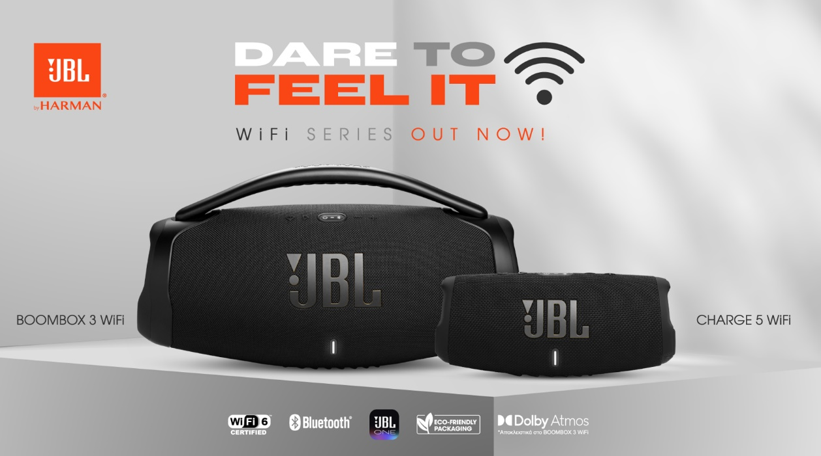

Athens, June 2023- JBL presents two iconic JBL portable speakers which have been upgraded with Wi-Fi connectivity. The JBL Boombox 3 Wi-Fi and JBL Charge 5 Wi-Fi speakers not only bring signature JBL sound via Bluetooth, but these new speakers also take it to the next level with high-quality audio streaming and new Wi-Fi capabilities.

Listen your way with the upgraded portable speakers and say goodbye to interruptions.
Continue scrolling and using your phone while streaming music to the speakers with the Wi-Fi connection. The music doesn’t have to stop when you leave the room or your device. Wi-Fi provides better range so you can take your speaker anywhere in the house. Or pop outside and switch to Bluetooth for total flexibility.

Looking for great sound everywhere you go? Self-tuning automatically detects when you’re in a new environment, so you can sit back and relax knowing the sound will be optimised, no matter if you’re listening inside or outdoors. With AirPlay 2, Alexa MRM and Chromecast built-in™ over Wi-Fi, connect and stream from your favourite music service. And with up to 20 hours of playback on the Charge 5 Wi-Fi and 24 hours on the Boombox 3 Wi-Fi, you can unplug and keep the party bouncing all night. The Boombox 3 Wi-Fi is also the first JBL portable speaker with Dolby Atmos for a more spatial and immersive sound experience.

Improved sound, new sleek design.
The new speakers arrive in a black colourway with eye-catching gold details. To make things even better, both speaker casings are now made from 90% post-consumer recycled plastic, and the speaker grille is made from 100% recycled fabric. Just like the originals, the new speakers are water and dustproof.

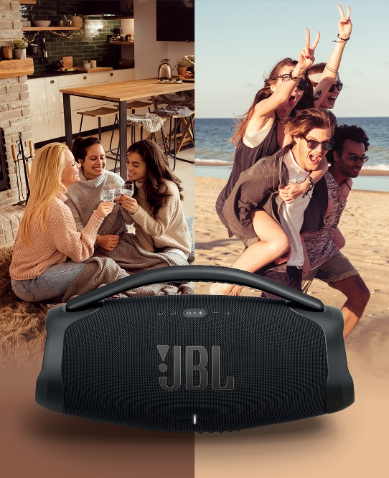
Features of the JBL Boombox 3 Wi-Fi
● Massive JBL Original Pro Sound and deepest bass
● 3-way speaker system consisting of subwoofer, two mid-range drivers and two tweeters
● Wi-Fi 6 for stable connection and high-quality audio streaming
● HD audio performance with 24bit/96kHz playback over Wi-Fi
● Bluetooth 5.3 (LE Audio Ready)
● 3D Dolby Atmos available through Tidal in-app via the JBL One app
● 24 hours of playtime
● AirPlay 2, Alexa MRM and Chromecast built-in™
● IP67 water and dustproof rating
● Powerbank
● Moment button to play playlists through the JBL One app on the speaker

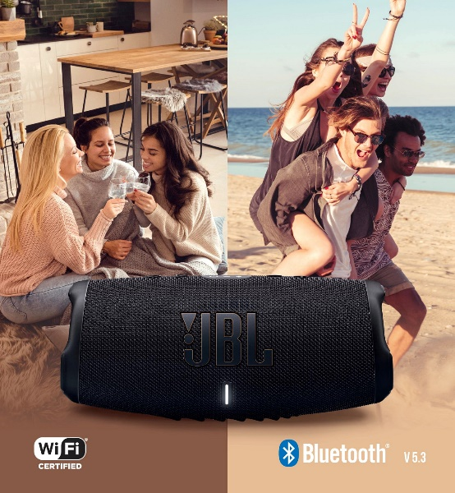
Features of the JBL Charge 5 Wi-Fi:
● Bold JBL Original Pro Sound
● Long excursion driver and a separate tweeter for better loudness and more clarity with two passive bass radiators
● Wi-Fi 6 for stable connection and high quality audio streaming
● HD audio performance with 24bit/96kHz playback over Wi-Fi
● Bluetooth 5.3 (LE Audio Ready)
● Powerbank
● 20 hours of playtime
● AirPlay 2, Alexa MRM and Chromecast built-in™
● IP67 water and dustproof rating
● Moment button to play playlists through the JBL One app on the speaker

The JBL Boombox 3 Wi-Fi and JBL Charge 5 Wi-Fi are available now in selected Retailers and Authorized Resellers for 629,00€ and 269,00€ respectively.

More information can be found at
Home | JBL (jblgreece.gr)
and our social account Facebook , Instagram, Tiktok
#JBLGreece #JBL #JBLwifiSeries #DaretoFeelit

About WaveMotion
WaveMotion, an importer and distributor, is seated in Athens Greece, operating on a wholesale basis, in the consumer electronics, telecommunications and computer industry for over 35 years. WaveMotion S.A. retains the official, exclusive, distribution for the Greek market of important Houses- in leading positions in the Global Arena, like JBL, harman/kardon, Cambridge Audio, Q Acoustics, QED, Goldring, rapoo, Native Union, Livall. Brand Development is the core skill of WaveMotion Team. The vision of our people is to expand WaveMotion’s Brands selection, following our tagline’s principles –Technology, Aesthetics, Design- and continue this journey of Ours, introducing compellingly and establishing decisively these Brands, in the eyes of our customers.
About VEESION (www.veesion.gr)
The independent advertising company VEESION was created in 2020 during the lockdown. Open to challenges and collaborations, it is a creative partner to companies in Greece and the United Arab Emirates, offering integrated communication services: Advertising, Branding, Digital & social media, Brand Experience, Video Content, Guerrilla & Growth Hacking Marketing. VEESION constantly invests in talented people with exceptional character, in new technologies and in training. VEESION's DNA consists of 4 main elements: Innovation, creativity, empathy and efficiency.
About HARMAN
HARMAN (harman.com) designs and engineers connected products and solutions for automakers, consumers, and enterprises worldwide, including connected car systems, audio and visual products, enterprise automation solutions; and services supporting the Internet of Things. With leading brands including AKG®, Harman Kardon®, Infinity®, JBL®, Lexicon®, Mark Levinson® and Revel®, HARMAN is admired by audiophiles, musicians and the entertainment venues where they perform around the world. More than 50 million automobiles on the road today are equipped with HARMAN audio and connected car systems. Our software services power billions of mobile devices and systems that are connected, integrated and secure across all platforms, from work and home to car and mobile. HARMAN has a workforce of approximately 30,000 people across the Americas, Europe, and Asia. In March 2017, HARMAN became a wholly owned subsidiary of Samsung Electronics Co., Ltd...

