For more information: Press Release
WaveMotion S.A For direct publication
Τηλ.:210-9244505 Date.: 25/05/2023
Fax: 211-0123494
Email: Partners@WaveMotion.gr
JBL most Innovative Headphones
at Headphones Show to INNOVATHENS

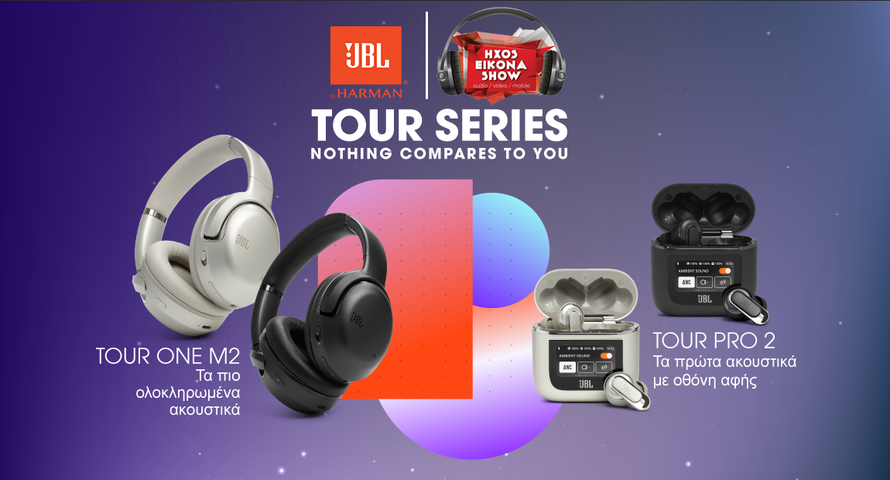

Athens, May 2023 - WaveMotion SA, Official Distributor of JBL lifestyle audio products for Greece, announces JBL’s participation in Headphones Show to INNOVATHENS at Technopolis City of Athens

Headphones Show is a spring headphone festival, an exhibition with the presence of hundreds of headphones, which will take place on Saturday 27th May 2023 to the modern INNOVATHENS building at Technopolis City of Athens.

JBL, together with its Legendary Pro Sound, comes to present the first headphone with a smart case, JBL Tour Pro 2, as well as the most inspiring over-ear headphones ,JBL Tour One M2. Nothing can compare to these two new headphones. Why? Because they have technological innovations (touch screen in the case), a combination of advantages (long battery life and True Adaptive Noise Canceling) and a unique design. Thus, the message "Nothing compares to you", has a double meaning: it describes the uniqueness of the products of the JBL TOUR series, but also the uniqueness of the users who use them.
At the same time, at our booth on the ground floor you will discover top selections of True Wireless, On-Over Ear and Gaming headphones, as well as a surprise giveaway. Designed with performance, some of the features they include are Adaptive Noise Cancelling paired with awesome JBL Pro Sound, so whatever your business, you can perform with confidence and in style, impressive battery life, Adaptive Ambient Aware and TalkThru technology. Don’t forget to take a look at our Gaming headsets, Quantum Series. The JBL Quantum range is engineered for the most realistic sound experience ever in a gaming headset. Amplifying every audible detail with pinpoint accuracy and immersive sound for a true competitive advantage, thanks to JBL QuantumSOUND Signature™. The flagship JBL Quantum ONE takes sound to the next level, built exclusively with JBL’s own QuantumSPHERE 360™ sound tech. Extensively tested with gamers around the world, the head tracker sensors and spatial audio will precisely locate and pair visual objects with their sound. Also, JBL expands its JBL Quantum gaming range with the brand’s first true wireless gaming earbuds. For gamers who prefer an in-ear, wire-free experience, the JBL Quantum TWS is here to deliver. Designed for mobile gaming on-the-go, make sure you never miss a beat of the action, wherever you are and however you choose to play.

Do you like relaxing and listening to your favorite music? Or spending hours in gaming? Or travelling all over the world along with your music? No matter, what type of auditor you are, you will find the headphones that fit you.
For the most demanding audiophiles, WaveMotion will present Cambridge Audio's DAC Magic 200, the headphone amplifier that uniquely enhances sound performance and letting all kinds of audio systems sound better than ever before!
We are waiting for you this Saturday 27th May at Technopolis City of Athens for a unique listening experience where the visitor will feel, hear and experience the limits of headphones’ technology.

Organiser: Magazine hxos+, Production: HXOS EIKONA SHOW
When: Saturday 27th May 2023 , 10.00 - 19.00 ,Where: ΙΝΝΟVΑΤΗΕΝS | Technopolis City of Athens
WEBSITE
Entrance is free

Follow us  @jbl_greece | jbl_greece |JBL Greece

About WaveMotion

WaveMotion, an importer and distributor, is seated in Athens Greece, operating on a wholesale basis, in the consumer electronics, telecommunications and computer industry for over 35 years. WaveMotion S.A. retains the official, exclusive, distribution for the Greek market of important Houses- in leading positions in the Global Sound Arena like JBL, harman/kardon, Cambridge Audio, Kef, Q Acoustics ,Audio Pro, QED and Goldring. Newly formed Lifestyle Technology acquired official distribution for rapoo, Livall, Native Union. Brand Development is the core skill of WaveMotion Team. The vision of our people is to expand WaveMotion’s Brands selection, following our tagline’s principles –Technology, Aesthetics, Design- and continue this journey of Ours, introducing compellingly and establishing decisively these Brands, in the eyes of our customers.

About HARMAN

HARMAN (harman.com) designs and engineers connected products and solutions for automakers, consumers, and enterprises worldwide, including connected car systems, audio and visual products, enterprise automation solutions; and services supporting the Internet of Things. With leading brands including AKG®, Harman Kardon®, Infinity®, JBL®, Lexicon®, Mark Levinson® and Revel®, HARMAN is admired by audiophiles, musicians and the entertainment venues where they perform around the world. More than 50 million automobiles on the road today are equipped with HARMAN audio and connected car systems. Our software services power billions of mobile devices and systems that are connected, integrated and secure across all platforms, from work and home to car and mobile. HARMAN has a workforce of approximately 30,000 people across the Americas, Europe, and Asia. In March 2017, HARMAN became a wholly-owned subsidiary of Samsung Electronics Co., Ltd.

