**For more information: Press Release**

**WaveMotion S.A** For direct publication

Τηλ.:210-9244505 Date.: 08/05/2023

Fax: 211-0123494

Email: [Partners@WaveMotion.gr](mailto:Partners@WaveMotion.gr)

**JBL ECO Series – Love Your Sound, Love the Planet!**

Athens, May 2023- New innovative eco-friendly design. Same rich JBL Pro Sound performance. The two portable favourites from JBL now deliver great sound and features, sustainably.

Created using 90% PCR plastic (Post Consumer Recycled) for the main construction with 100% recycled fabric on the speaker grille, the new portables also arrive in JBL’s most sustainable packaging yet. The new innovative eco-friendly design significantly reduces the amount of virgin plastic being used which not only recycles waste plastic, but also the overall carbon footprint of the product.

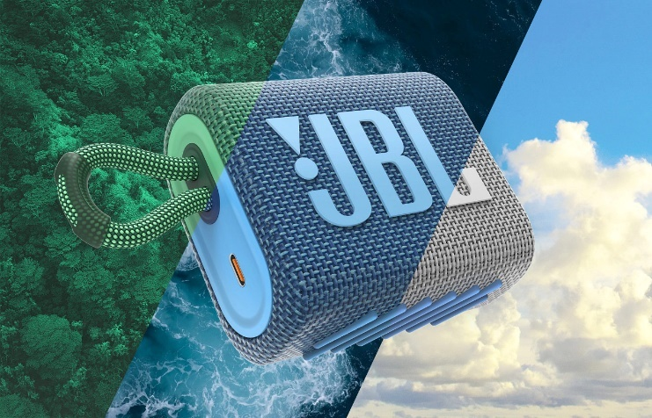

**JBL GO3 ECO**

The pocket-size JBL Go 3 Eco is the ultra-portable speaker in the JBL range. Power it up and prepare to be surprised. This mini speaker plays on for five hours on one charge, delivering rich JBL Pro Sound and punchy bass. At the beach or in the park, the IP67 waterproof and dustproof JBL Go 3 Eco never fails to set the stage for fun.

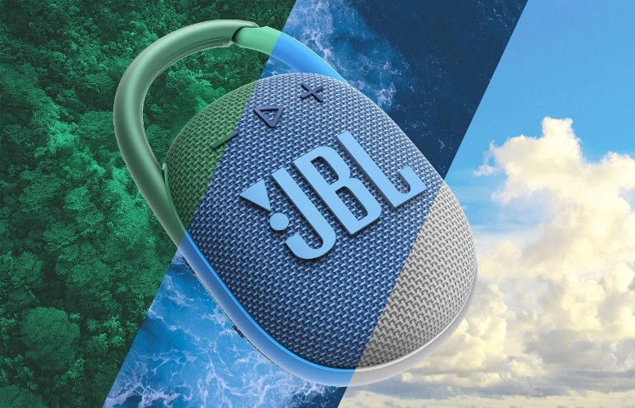**JBL Clip 4 ECO**

The compact JBL Clip 4 Eco packs 10 hours of playtime and big bass performance into a compact and convenient speaker. The integrated clip can take whatever life throws at it, so hook it onto a backpack or bike as the Clip 4 Eco supplies the soundtrack for your adventures.

The JBL Go 3 Eco and JBL Clip 4 Eco are now available in Forest Green, Ocean Blue and Cloud White in selected Retailers and Authorized Resellers for €44,95 and €64,95 respectively. More information can be found at [www.jblgreece.gr](http://www.jblgreece.gr).

**For more info visit:**

[Home | JBL (jblgreece.gr)](https://www.jblgreece.gr/)

Instagram Update Adds Emoji Shortcuts Bar for Faster Comments - MacRumors[**@jbl_greece**](https://www.instagram.com/jbl_greece/)

[**JBL Greece**](https://www.facebook.com/JBLGreece)

Emoji Face created by Tik Tok Asistant | Popular songs on TikTok[jbl_greece](https://www.tiktok.com/@jbl_greece?lang=en)

**About WaveMotion**

WaveMotion, an importer and distributor, is seated in Athens Greece, operating on a wholesale basis, in the consumer electronics, telecommunications and computer industry for over 35 years. WaveMotion S.A. retains the official, exclusive, distribution for the Greek market of important Houses- in leading positions in the Global Arena, like JBL, harman/kardon, Cambridge Audio, Q Acoustics, QED, Goldring, rapoo, Native Union, Livall. Brand Development is the core skill of WaveMotion Team. The vision of our people is to expand WaveMotion’s Brands selection, following our tagline’s principles –Technology, Aesthetics, Design- and continue this journey of Ours, introducing compellingly and establishing decisively these Brands, in the eyes of our customers.

**About VEESION (www.veesion.gr)**

The independent advertising company VEESION was created in 2020 during the lockdown. Open to challenges and collaborations, it is a creative partner to companies in Greece and the United Arab Emirates, offering integrated communication services: Advertising, Branding, Digital & social media, Brand Experience, Video Content, Guerrilla & Growth Hacking Marketing. VEESION constantly invests in talented people with exceptional character, in new technologies and in training. VEESION's DNA consists of 4 main elements: Innovation, creativity, empathy and efficiency.

**About HARMAN**

HARMAN (harman.com) designs and engineers connected products and solutions for automakers, consumers, and enterprises worldwide, including connected car systems, audio and visual products, enterprise automation solutions; and services supporting the Internet of Things. With leading brands including AKG®, Harman Kardon®, Infinity®, JBL®, Lexicon®, Mark Levinson® and Revel®, HARMAN is admired by audiophiles, musicians and the entertainment venues where they perform around the world. More than 50 million automobiles on the road today are equipped with HARMAN audio and connected car systems. Our software services power billions of mobile devices and systems that are connected, integrated and secure across all platforms, from work and home to car and mobile. HARMAN has a workforce of approximately 30,000 people across the Americas, Europe, and Asia. In March 2017, HARMAN became a wholly owned subsidiary of Samsung Electronics Co., Ltd...