For more information: Press Release
WaveMotion S.A For direct publication
Τηλ.:210-9244505 Date.: 13/03/2023
Fax: 211-0123494
Email: Partners@WaveMotion.gr
JBL TOUR SERIES
Nothing compares to you!

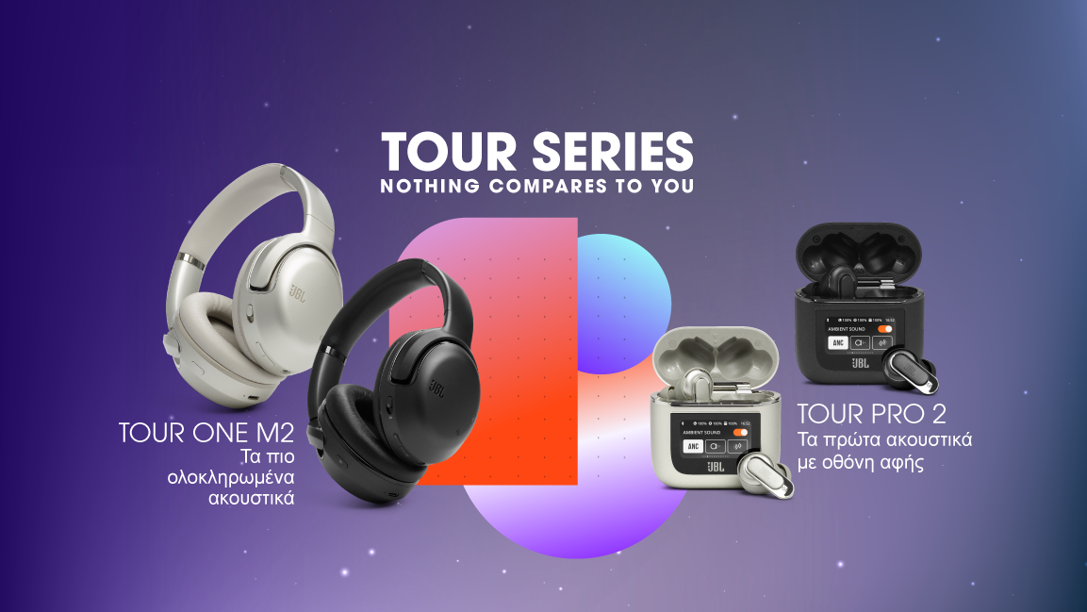

Athens , March 2023- Just arrived….the most powerful and feature-rich headphones yet - the JBL Tour PRO 2 True Wireless Earbuds and the JBL Tour ONE M2 . The latest additions to the JBL Tour lineup push performance to the next level with a smart, seamless user experience and superior audio, including immersive JBL Spatial Audio and the first true wireless earbuds to be encased in JBL’s innovative smart case. The message "Nothing compares to you", has a double meaning: it describes the uniqueness of JBL TOUR series, but also the uniqueness of the users who use them.

Featuring the world’s first smart charging case and best ever JBL ANC performance.

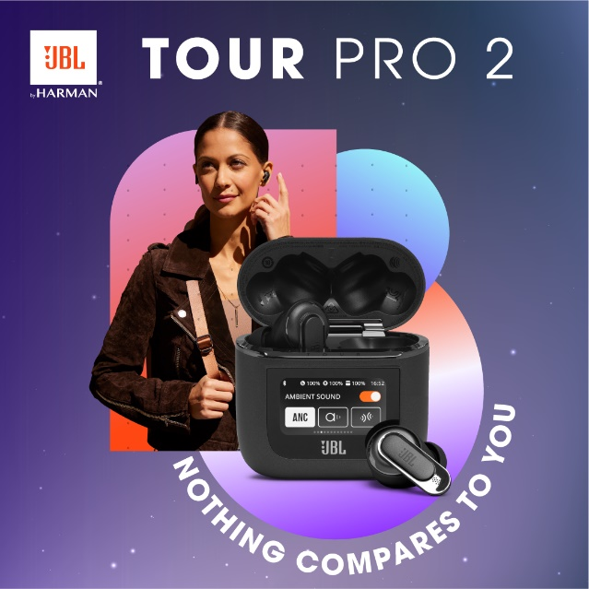
JBL Tour PRO 2 launches with the world’s first smart charging case. Transform your TWS experience beyond audio - just tap the 1.45" inch LED touch display to manage your music, customize your earbuds, receive calls, messages and social media notifications in real time without touching your phone. Simplified navigation and customisation without the need to take out your phone or open the JBL Headphones app connects you to the things that matter most. Built for productivity, designed to inspire. Optimize the ANC performance, take the Ear Canal Test in a noisy environment then relax or work in pure silence as the software does the rest. If you need to take a call, the 6 mic design guarantees crystal clear audio. With the JBL Tour PRO 2, you will sound as good as you look.

Pricing and Availability
JBL Tour PRO 2 is available now in selected Retailers and Authorized Resellers for 299,00€. More information on JBL Tour PRO 2 can be found at www.wavemotion.gr

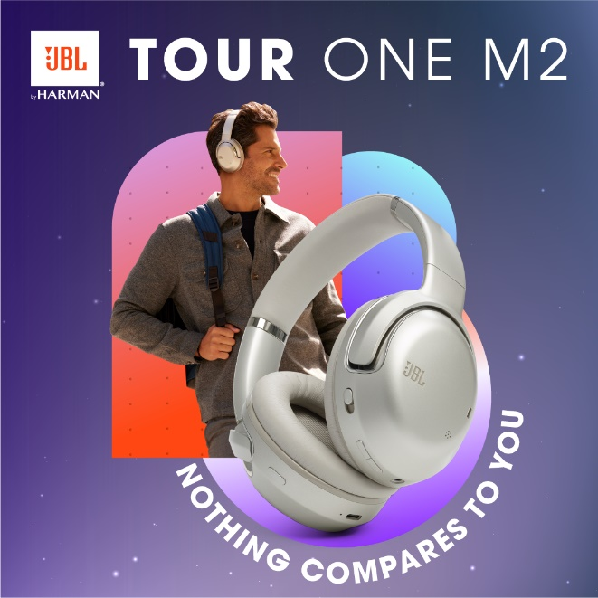
Outperforming the competition and JBL’s own previous headphones, the JBL Tour ONE M2 combines JBL’s best-ever hybrid True Adaptive ANC with JBL Pro-tuned drivers to fill your ears with only the best sound whether on-the-go, at work or at home. True Adaptive ANC technology automatically adjusts to the surroundings in real time, eliminating distractions and maximizing your listening experience. Advanced built-in voice recognition reacts to your voice, pauses the music and enables Ambient Aware. Ready to get back to it? Music and JBL’s next level True Adaptive ANC automatically resume once the conversation is over. With up to 50 hours of playtime, or 30 hours with ANC activated, they’ll outlast even the longest trip. Forgot to charge and need to dash? Fast charge means 10 minutes plugged in and you’ll be free for 5 hours of legendary JBL Pro Sound. Set up a customized hearing profile with HARMAN’s advanced Personi-Fi 2.0 for the ultimate personalized sound performance.

Pricing and Availability
JBL Tour ONE M2 is available now in selected Retailers and Authorized Resellers for 369,00€. More information on JBL Tour ONE M2 can be found at www.wavemotion.gr

For more info visit:
Home | JBL (jblgreece.gr)
 @jbl_greece
 JBL Greece
jbl_greece

About WaveMotion
WaveMotion, an importer and distributor, is seated in Athens Greece, operating on a wholesale basis, in the consumer electronics, telecommunications and computer industry for over 35 years. WaveMotion S.A. retains the official, exclusive, distribution for the Greek market of important Houses- in leading positions in the Global Arena, like JBL, harman/kardon, Cambridge Audio, Q Acoustics, QED, Goldring, rapoo, Native Union, Livall. Brand Development is the core skill of WaveMotion Team. The vision of our people is to expand WaveMotion’s Brands selection, following our tagline’s principles –Technology, Aesthetics, Design- and continue this journey of Ours, introducing compellingly and establishing decisively these Brands, in the eyes of our customers.
About VEESION (www.veesion.gr)
The independent advertising company VEESION was created in 2020 during the lockdown. Open to challenges and collaborations, it is a creative partner to companies in Greece and the United Arab Emirates, offering integrated communication services: Advertising, Branding, Digital & social media, Brand Experience, Video Content, Guerrilla & Growth Hacking Marketing. VEESION constantly invests in talented people with exceptional character, in new technologies and in training. VEESION's DNA consists of 4 main elements: Innovation, creativity, empathy and efficiency.
About HARMAN
HARMAN (harman.com) designs and engineers connected products and solutions for automakers, consumers, and enterprises worldwide, including connected car systems, audio and visual products, enterprise automation solutions; and services supporting the Internet of Things. With leading brands including AKG®, Harman Kardon®, Infinity®, JBL®, Lexicon®, Mark Levinson® and Revel®, HARMAN is admired by audiophiles, musicians and the entertainment venues where they perform around the world. More than 50 million automobiles on the road today are equipped with HARMAN audio and connected car systems. Our software services power billions of mobile devices and systems that are connected, integrated and secure across all platforms, from work and home to car and mobile. HARMAN has a workforce of approximately 30,000 people across the Americas, Europe, and Asia. In March 2017, HARMAN became a wholly owned subsidiary of Samsung Electronics Co., Ltd...

