For more information: Press Release
WaveMotion S.A For direct publication
Τηλ.:210-9244505 Hμ.:
Fax: 211-0123494
Email: Partners@WaveMotion.gr
What’s the sound of …. Jingle BelLs?

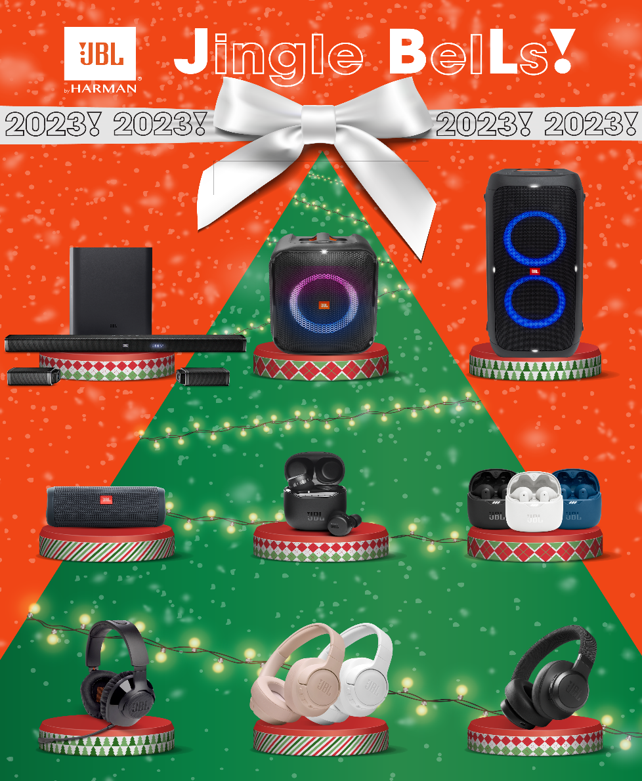

Do you recognize their sound? Since when have you heard your favorite Christmas Carols? Did you leave them behind in your childhood when you got your last present from Santa Claus?

This year, JBL awakens the magical sound in you, with gadgets that bring the spirit of Christmas to life and will accompany you throughout the new year: Listen to one - or more - of the legendary sounds that fit to you:

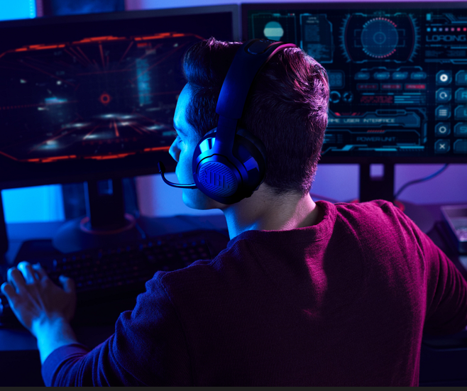
Are you a gamer? Ready to level up your gameplay? Meet the JBL Quantum 350 Wireless gaming headset.
If you asked Santa for a toy, you'll definitely need the best audio gadget to enjoy them… JBL Quantum 350!
From the quietest footsteps to the loudest laser blasts, JBL’s QuantumSOUND Signature puts you in the center of every scene. No matter how crazy the action gets, the detachable, directional voice focus boom mic means other players can always hear you clearly. Lossless wireless, 22-hour battery life and lightweight memory foam ear cushions mean you’ll never miss a second of mayhem during even your longest gaming sessions. JBL QuantumENGINE PC software fine-tunes the sound for the ultimate competitive advantage. Your opponents won’t know what hit them..

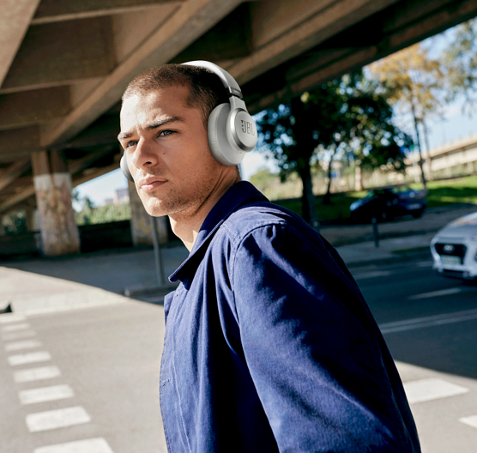
Are you looking for dedication? The ideal headphones are Live 660NC!
In your world, music is essential, so slip on a pair of JBL Live 660NC and elevate your day. Blasting powerful 40mm drivers, the JBL Live 660NC headphones deliver JBL Signature Sound punctuated with enhanced bass, so every track pops. And when the music is the only thing that matters, the Adaptive Noise Cancelling technology allows you to block-out ambient sounds so nothing disturbs your groove. Ambient Aware keeps you safe while walking in the streets with your music on and TalkThru allows you to have quick chats without removing your JBL Live 660NC. Need some help getting through the day? Get help from your preferred voice assistant through your voice or with a tap on the earcup. And if you set-up Hey Google, activate your JBL Live 660NC features only using your voice. Magic!

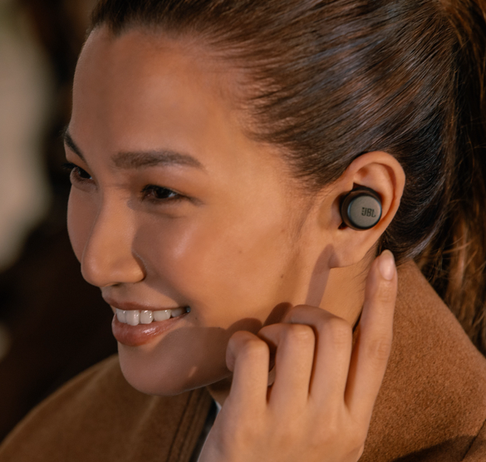
Are you unstoppable? Choose Tour Pro+ TWS!
What if you travel to the North Pole and back again, your Tour Pro+ TWS headphones will continue to give you the ultimate, legendary JBL sound, since they boasting 32 hours of wirelessly rechargeable battery life and a compatible app for ultimate customization. These sleek in-ear headphones keep you inspired and engaged with Adaptive Noise Cancelling technology and Smart Ambient to control the sounds around you. From the moment you open the case, you’ll immediately enjoy smart features created to boost your productivity and unrivaled comfort fit. 3-mic technology ensures high-quality calls even in noisy or windy environments. You’ll be ready to get down to business or cut loose wherever your adventures may lead.

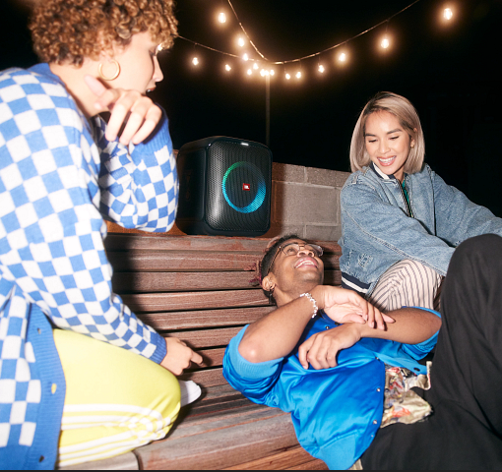
Partybox Encore Essential… Your grab & go party!!
The portable JBL PartyBox Encore Essential speaker gives you 6 hours of non-stop fun. With an easy grab-and-go handle and splash proof design, you can always take the party with you. Keep the music pumping anywhere with amazing JBL Original Pro Sound and deep bass. Let the cool built-in light show set the mood, or use True Wireless Stereo technology to pair up speakers for an even bigger sound. You’re always in control with the PartyBox app, which lets you customize your music and lightshow colors to create the perfect vibe.


Take your tunes on the go with the powerful JBL Flip Essential 2.

You see it small and you don't realize how big it is when you just put it play! For 10 playtime hours it will surprise you, taking your favorite Xmas playlist on the go with the powerful JBL Flip Essential 2! And if the weather turns bad? No need to worry. With its waterproof design, you can continue to enjoy JBL's legendary sound whether it's rain or New Year's snow!

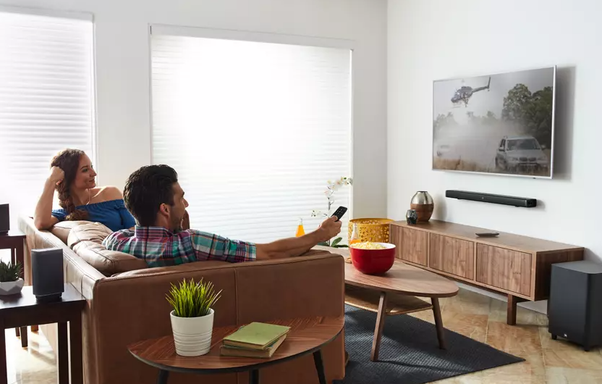
Watch xmas movies, feel the ultimate all-wireless movie experience with Bar 51, 5.1 True Wireless Soundbar

Are you home alone? Absolutely not! You have the best company to enjoy your favorite movie… Bar 51, 5.1 True Wireless Soundbar which transforms from a soundbar into a true wireless 5.1 home theater system for an epic movie and music-listening experience. The soundbar features two detachable battery powered wireless surround speakers with 10-hours of playtime, 510W of total system power, a 10” wireless subwoofer, three HDMI™ inputs to connect 4K devices and Bluetooth™. With Dolby® Digital, Dolby Pro Logic II and DTS, your movies, music and video games will never sound more incredible. The soundbar features JBL SoundShift®, which allows you to instantly switch between the sound from your TV and the Bluetooth sound from your mobile phone or tablet. The soundbar is programmed to respond to your TV remote, so you can control everything with your existing TV remote control. The JBL Bar 5.1 re-defines the soundbar experience.

For more info visit:
Home | JBL (jblgreece.gr)
 @jbl_greece
jbl_greece

 JBL Greece

About WaveMotion
WaveMotion, an importer and distributor, is seated in Athens Greece, operating on a wholesale basis, in the consumer electronics, telecommunications and computer industry for over 35 years. WaveMotion S.A. retains the official, exclusive, distribution for the Greek market of important Houses- in leading positions in the Global Arena, like JBL, harman/kardon, Cambridge Audio, Q Acoustics, QED, Goldring, rapoo, Native Union, Livall. Brand Development is the core skill of WaveMotion Team. The vision of our people is to expand WaveMotion’s Brands selection, following our tagline’s principles –Technology, Aesthetics, Design- and continue this journey of Ours, introducing compellingly and establishing decisively these Brands, in the eyes of our customers.
About VEESION (www.veesion.gr)
The independent advertising company VEESION was created in 2020 during the lockdown. Open to challenges and collaborations, it is a creative partner to companies in Greece and the United Arab Emirates, offering integrated communication services: Advertising, Branding, Digital & social media, Brand Experience, Video Content, Guerrilla & Growth Hacking Marketing. VEESION constantly invests in talented people with exceptional character, in new technologies and in training. VEESION's DNA consists of 4 main elements: Innovation, creativity, empathy and efficiency.
About HARMAN
HARMAN (harman.com) designs and engineers connected products and solutions for automakers, consumers, and enterprises worldwide, including connected car systems, audio and visual products, enterprise automation solutions; and services supporting the Internet of Things. With leading brands including AKG®, Harman Kardon®, Infinity®, JBL®, Lexicon®, Mark Levinson® and Revel®, HARMAN is admired by audiophiles, musicians and the entertainment venues where they perform around the world. More than 50 million automobiles on the road today are equipped with HARMAN audio and connected car systems. Our software services power billions of mobile devices and systems that are connected, integrated and secure across all platforms, from work and home to car and mobile. HARMAN has a workforce of approximately 30,000 people across the Americas, Europe, and Asia. In March 2017, HARMAN became a wholly owned subsidiary of Samsung Electronics Co., Ltd...

