For more information: Press Release
WaveMotion S.A For direct publication
Τηλ.:210-9244505 Hμ.: 19/09/2022
Fax: 211-0123494
Email: Partners@WaveMotion.gr
JBL is back to…
Start Together, JBL Forever

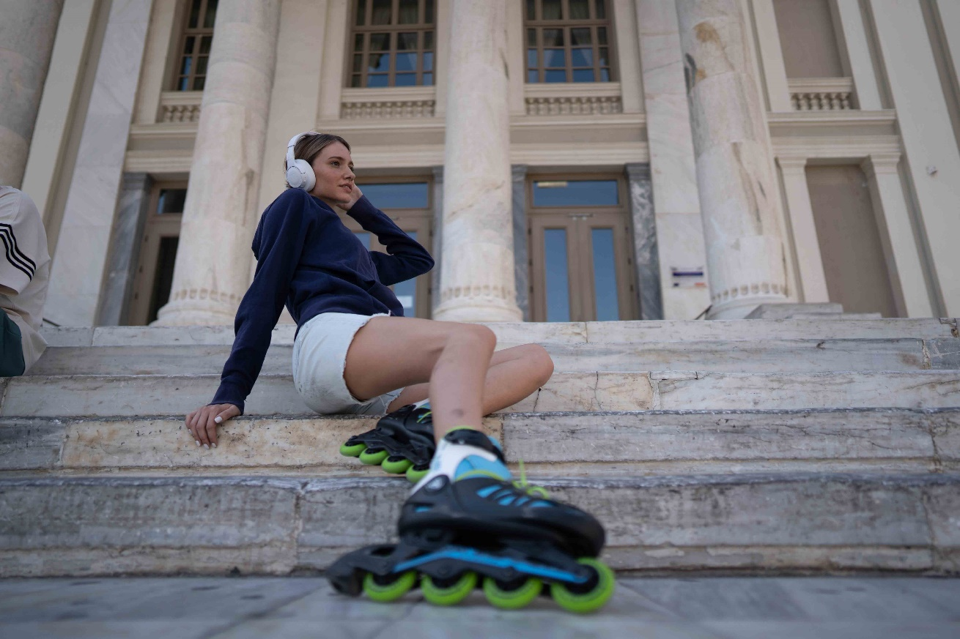

The JBL Original Pro Sound stays along in all our new beginnings, in the new era!
In the new campaign "Back to..." we preferred to replace the concept "return to everyday life" and focus on the concept of "new beginnings".

Our four heroes of this new campaign, each one with different activities and interests, start new hobbies, new habits and set new goals, always with the best company, their JBL legendary headsets and speakers! They meet on the first day of school, discover new city hot spots, set up impromptu parties at home or on the streets, play games for hours, study or develop their careers.
Along with them, the protagonists are the JBL True Wireless Headphones of Wave Series, the Headphones Tune 660NC & 760NC, Gaming headset Quantum 350 & Quantm TWS, Bluetooth mini speakers Go Essential & Go 3, the waterproof and high-performance speaker Flip 6, Charge 5, & Boombox 2 and the impressive in size and sound quality, JBL PartyBox 710.
And because some things last forever, JBL does not forget the legendary past. So, in the new campaign, events, world days and celebrations are combined, creating new season’s calendar. Every day becomes a legendary day and the JBL legendary sound fills the accompanied soundtrack, so…
START TOGETHER
JBL FOREVER

For more info visit:
Home | JBL (jblgreece.gr)
 @jbl_greece
JBL Greece

#start_together #JBL_forever

Credits
Agency: Veesion
Photographer: Malliaris Panagiotis
Videographer: Alexandros Lazaridis

About WaveMotion
WaveMotion, an importer and distributor, is seated in Athens Greece, operating on a wholesale basis, in the consumer electronics, telecommunications and computer industry for over 35 years. WaveMotion S.A. retains the official, exclusive, distribution for the Greek market of important Houses- in leading positions in the Global Arena, like JBL, harman/kardon, Cambridge Audio, Q Acoustics, QED, Goldring, rapoo, Native Union, Livall. Brand Development is the core skill of WaveMotion Team. The vision of our people is to expand WaveMotion’s Brands selection, following our tagline’s principles –Technology, Aesthetics, Design- and continue this journey of Ours, introducing compellingly and establishing decisively these Brands, in the eyes of our Customers.
About VEESION (www.veesion.gr)
The independent advertising company VEESION was created in 2020 during the lockdown. Open to challenges and collaborations, it is a creative partner to companies in Greece and the United Arab Emirates, offering integrated communication services: Advertising, Branding, Digital & Social Media, Brand Experience, Video Content, Guerrilla & Growth Hacking Marketing. VEESION constantly invests in talented people with exceptional character, in new technologies and in training. VEESION's DNA consists of 4 main elements: Innovation, creativity, empathy and efficiency.
About HARMAN
HARMAN (harman.com) designs and engineers connected products and solutions for automakers, consumers, and enterprises worldwide, including connected car systems, audio and visual products, enterprise automation solutions; and services supporting the Internet of Things. With leading brands including AKG®, Harman Kardon®, Infinity®, JBL®, Lexicon®, Mark Levinson® and Revel®, HARMAN is admired by audiophiles, musicians and the entertainment venues where they perform around the world. More than 50 million automobiles on the road today are equipped with HARMAN audio and connected car systems. Our software services power billions of mobile devices and systems that are connected, integrated and secure across all platforms, from work and home to car and mobile. HARMAN has a workforce of approximately 30,000 people across the Americas, Europe, and Asia. In March 2017, HARMAN became a wholly-owned subsidiary of Samsung Electronics Co., Ltd..

