For more information: Press Release
WaveMotion S.A For direct publication
Τηλ.:210-9244505 Hμ.:
Fax: 211-0123494
Email: Partners@WaveMotion.gr

WaveMotion presents LIVALL
@ 2nd Electric & Micro Mobility FORUM

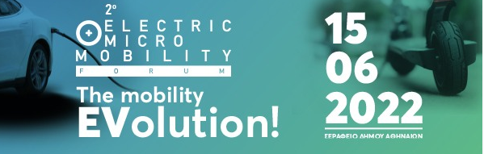

Athens, June 4th, 2022. -WaveMotion Α.Ε., official distributor of LIVALL Smart Helmets announces its participation at 2nd Electric & Micro Mobility FORUM.

Electric & Micro Mobility FORUM is organized for a 2nd year by “Smart Press Media Company” and “GetElectric.gr”, a specialized Web site dedicated to Micro Mobility concept.
The Forum wishes to explore the future of Transport and its transformation thanks to electro- and micro mobility. At the same time, the conference will highlight the ways in which new transportation technologies will improve our lives individually as well as on a national level, problems that might arise in this context and the ways to overcome them, in alignment with other European countries.

During the Forum, WaveMotion will proudly present LIVALL, world's first smart and safety cycling helmet brand.
LIVALL is the leading pioneer in the smart helmet industry, offering the most forward-thinking and advanced technologies available on the market.
LIVALL emphasizes in safety and technology and takes a sophisticated approach to its helmets through continual R&D, and by considering the impact its products have on consumers and the planet.
Participants of 2nd Electric & Micro Mobility FORUM will have the chance to visit WaveMotion’s kiosk and try LIVALL ‘s offerings for the very first time!

LIVALL Products Range
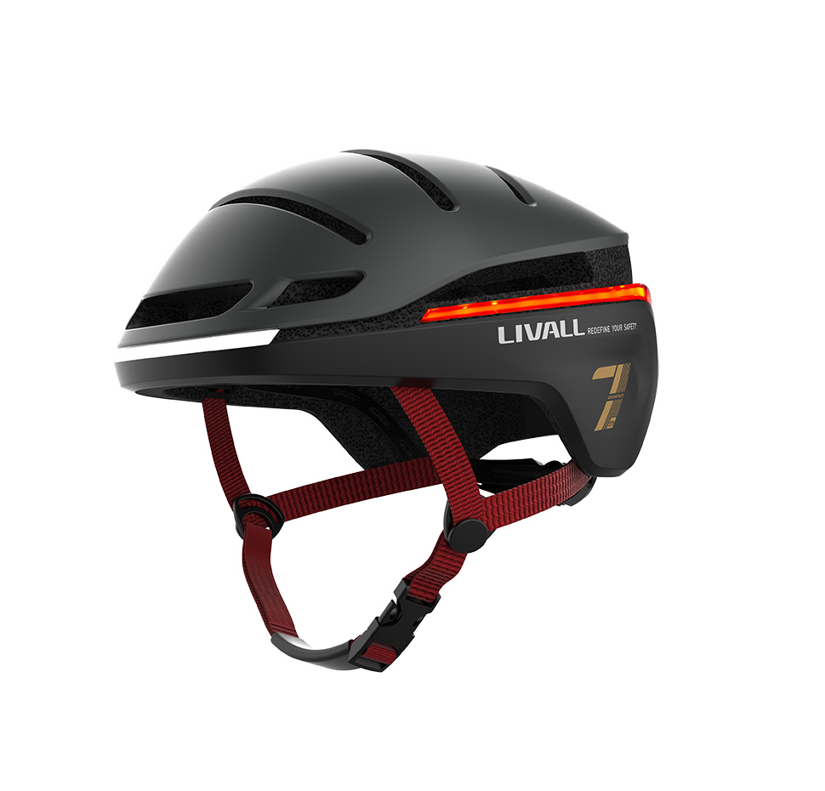
ΕVO 21 is the crowning achievement of LIVALL. It’s time to take your helmet even further. It is the smartest lighting helmet in the world that will ‘redefine your safety' and for better. The LIVALL EVO21 has been designed based on 3 core principles- Brighter, Lighter, and Safer. Other brands claim to give you 360° visibility, but they often fall short. The LIVALL EVO21 Smart Helmet offers true 360° coverage, with a brake warning light and turn signals for visibility from all directions. Plus, 3 dynamic light effects will make you hard to miss on the road, you can ride with your peace of mind as well as ride in style. With 30% more ventilation and 350g lightweight design, you’ll stay ahead of the pack while cutting down on sweat with the LIVALL EVO21 Smart Helmet. The LIVALL EVO21 Smart Helmet features patented fall detection and SOS technology. So in the event of a fall it sends a text message alert to your emergency contact with your exact GPS location.

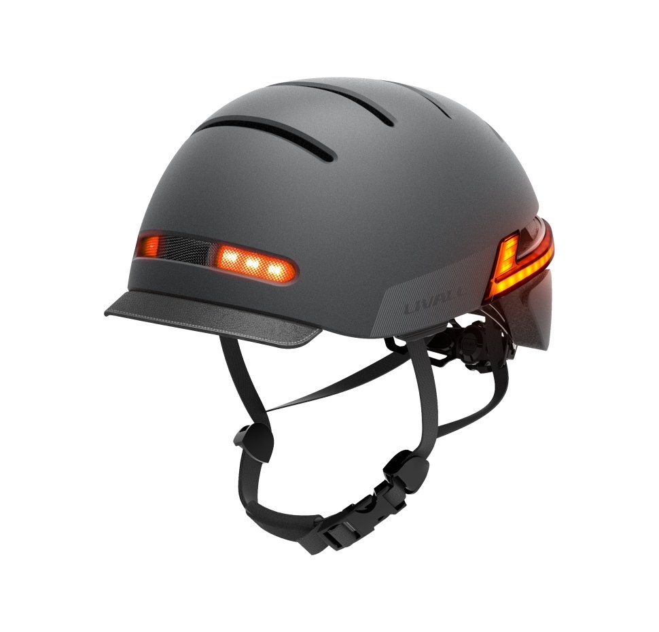
The BH51M NEO is the new flagship model from LIVALL. It is world’s favorite smart helmet for anyone who likes to travel around the city. Whether you’re on the go by bike, e-bike, skateboard, inline skates, longboard or city scooter, the BH51M NEO feels the most comfortable on the head of the modern city athlete. This helmet is simple-to-use, packed full of genuinely useful smart features; it’s perfect for the commuter or leisure cyclist. It also features two Bluetooth stereo speakers and windproof hands-free microphone enable you to listen to music on the go, answer phone calls remotely, and hear GPS sat nav directions while still being aware of your surroundings.

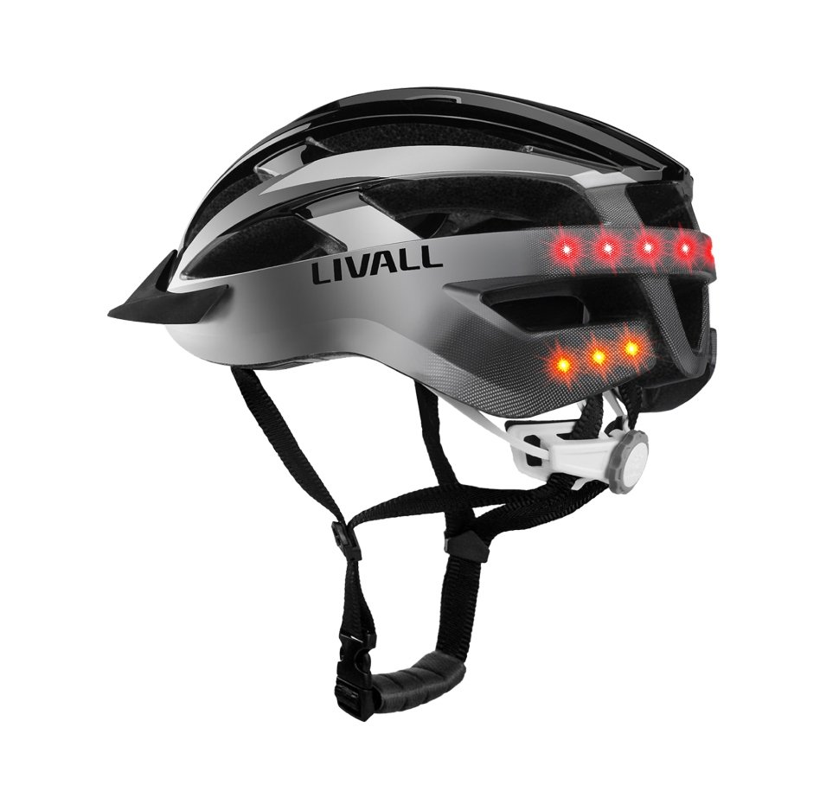

The best helmet to experience the thrill of the wild is the LIVALL MT1 Mountain Bike Smart model, a multifunctional lightweight smart helmet that combines safety with connectivity. It has many high-tech features that makes it perfect for the cyclist who like to go off the road. Some of them are: LED safety lights, handlebar remote control, stereo speakers and Bluetooth technology to connect your smartphone.

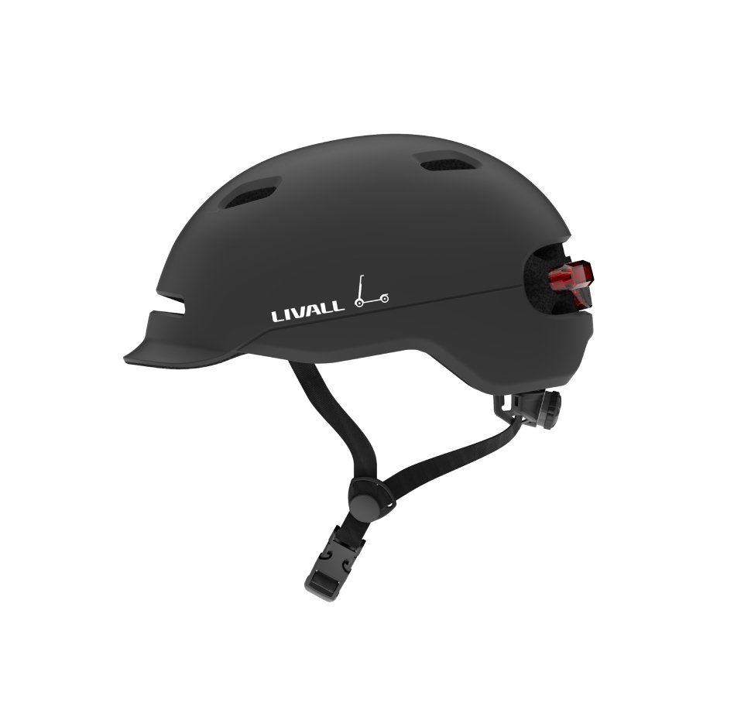
The LIVALL C20 provides more visibility with increased lighting. Great for gifting by helping a loved one to enjoy their commute more with the SMART features, while also helping them be more visible to the surrounding traffic. Not forgetting the peace of mind for everyone at home with the SOS alert.

EVO 21, BH51M NEO, MT1 and C20 helmets are available now in Authorized Resellers for 149,00€, 179,00€, 119,00€ and 69,95€ respectively. More information can be found at LIVALL | WaveMotion S.A.

About WaveMotion
WaveMotion, an importer and distributor, is seated in Athens Greece, operating on a wholesale basis, in the consumer electronics, telecommunications and computer industry for over 35 years. WaveMotion S.A. retains the official, exclusive, distribution for the Greek market of important Houses- in leading positions in the Global Sound Arena like JBL, harman/kardon, Cambridge Audio, Kef, Q Acoustics, QED and Goldring.
Newly formed Lifestyle Technology acquired official distribution for rapoo, Livall, Native Union.
Brand Development is the core skill of WaveMotion Team. The vision of our people is to expand WaveMotion’s Brands selection, following our tagline’s principles –Technology, Aesthetics, Design- and continue this journey of Ours, introducing compellingly and establishing decisively these Brands, in the eyes of our customers.

About LIVALL

Founded in 2014 and released the world's first smart & safety cycling helmet in February 2015, LIVALL Tech Co., Ltd. is adept at developing, designing, and manufacturing fashionable and multifunctional patented helmet phones to maximize riders' safety. Committed to becoming the world's best innovative company in the segmented field of smart safety protection equipment, LIVALL has strict standards and massive production capacity to meet the huge market demand. It has obtained more than 170 patents, 30 awards and over 10 international certifications such as CPSC1203, EN1078, CE, FCC, NCC, ROHS, BQB, etc.

