For more information: Press Release
WaveMotion S.A For direct publication
Τηλ.:210-9244505 Hμ.:
Email: Partners@WaveMotion.gr

Premium Audio Brand KEF
is the new addition
to WaveMotion’s Home Audio portfolio of Brands

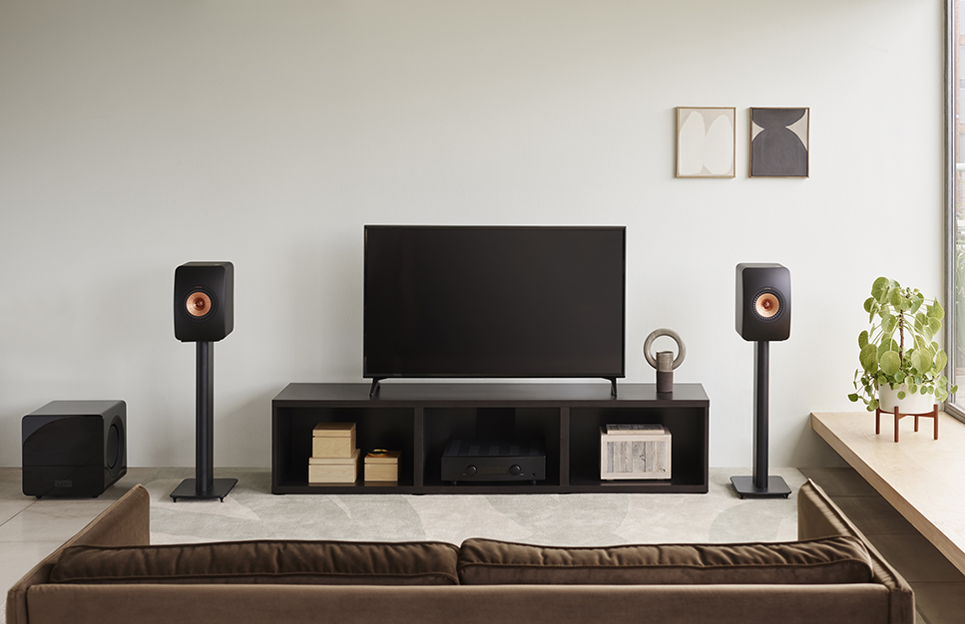

Athens, October 2021. – WaveMotion SA announces the official distribution for Greece of KEF, enhancing further its Home Audio Brands portfolio.

KEF is a proud pioneer of excellence in sound. Since 1961, from UK home, they have created remarkable – award-winning – speakers. From their ground-breaking Uni-Q technology to their bar-setting LS50 Wireless, KEF exists to fill rooms with music as it was made to be heard, to move souls with truly authentic soundscapes. KEF is named after Kent Engineering and Foundry where their story began. Their founder Raymond Cooke was propelled by a love of music and a refusal to compromise and leveraged technology at every turn to ensure KEF’s position at the cutting edge of audio.

Why KEF?
Best KEF speakers 2021: budget, premium, bookshelf and standmount by What Hi-Fi.
Most of KEF's speakers feature the firm's innovative Uni-Q driver. Rather than having a separately mounted tweeter and midrange driver, the tweeter is set into the centre of the mid. A simple idea – but it's what sets the company apart from the pack. More importantly, KEF has kept pace with the times and diversified into wireless speakers, including Bluetooth desktop speakers and wireless all-in-one streaming systems such as the magnificent LSX.

KEF’S Collection includes Wireless Hi-fi speakers, Hi-fi Speakers & Subwoofers.

Wireless Hi-fi Speakers

LSX, LS50 Wireless II, LS50Meta.

Play anything. Hear everything.
Drawing on decades of acoustic expertise, KEF’s range of wireless audio systems are designed for how we listen to music today. So you can enjoy all the effortless convenience of digital, with the emotional depth and realism of true HiFi. For more information: Wireless Hi-fi Speakers Archives | WaveMotion S.A.

Hi-fi Speakers
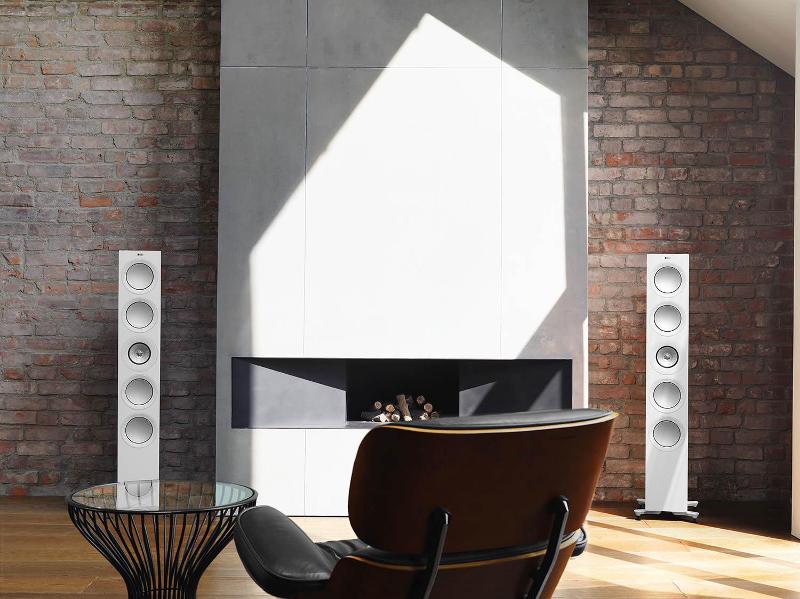
R Series. Science of Sound
Decades of experience and our unbridled passion for music come together in the R Series. Combining innovations from the Reference Series with bespoke technologies the new R Series delivers more detail, deeper insight and greater excitement. When you want to forget the world and simply lose yourself in sound, R Series will take you there. At KEF, the quest to develop perfect loudspeakers has lasted more than 50 years. Like you, we don’t just want to hear music; we want to experience it, get inside it and feel part of it. For more information: R Series Archives | WaveMotion S.A.

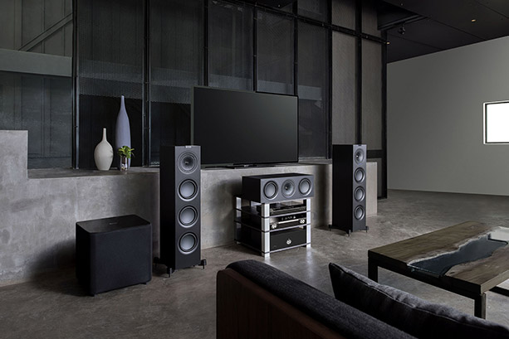
Q Series. Award-winning Depth and Clarity
Representing exceptional value, Q Series unlocks detail and depth in whatever you choose to listen to. The Q Series has an option for everybody and every room. Three floorstanding models and two bookshelf speakers, ensure that no matter the room size or personal preference, the Q Series can deliver an engaging, room-filling experience. The Q Series continues to win awards globally by unlocking unparalleled detail and depth forin its class. For more information: Q Series Archives | WaveMotion S.A.

Subwoofers
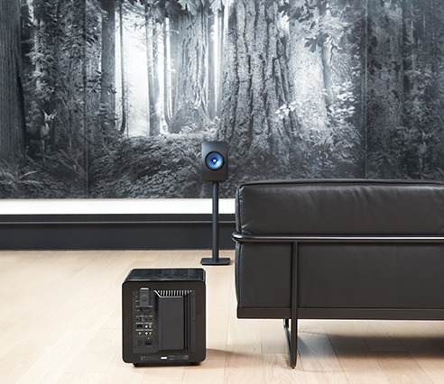
KEF’s comprehensive range of subwoofers deliver depth and accuracy in equal measures. Room-friendly designs and innovative technology keep them ahead of the pack, so it’s just a case of selecting the one that best suits your needs.

Why KEF Subwoofers?
At its most basic a subwoofer needs to be able to produce deep and loud bass. KEF subwoofers are anything but basic. Each subwoofer is full of exceptional engineering and innovation in the form of cutting-edge technologies such as Uni-Core™ and KEF’s Music Integrity Engine and are designed to deliver depth and accuracy in equal measures. KEF subwoofers are also versatile, whether you want them for music, movies, or a mixture of both, for small spaces and large listening rooms, the comprehensive line-up has a high-performance subwoofer to suit.
For more information: Wavemotion eShop - All around sound systems & accessories

You can find KEF’s Collection of Wireless Hi-fi speakers, Hi-fi Speakers & Subwoofers, now in Authorized Resellers and with pricing starting at €478,00 offering various price levels always achieving best value for money, offerings. For more information: Kef | WaveMotion S.A.

About WaveMotion
WaveMotion, an importer and distributor, is seated in Athens Greece, operating on a wholesale basis, in the consumer electronics, telecommunications and computer industry for over 35 years. WaveMotion S.A. retains the official, exclusive, distribution for the Greek market of important Houses- in leading positions in the Global Arena, like JBL, harman/kardon, Cambridge Audio, Q Acoustics, QED, Goldring, rapoo, Native Union, Livall. Brand Development is the core skill of WaveMotion Team. The vision of our people is to expand WaveMotion’s Brands selection, following our tagline’s principles –Technology, Aesthetics, Design- and continue this journey of Ours, introducing compellingly and establishing decisively these Brands, in the eyes of our Customers.

About KEF
KEF was founded in 1961 by Raymond Cooke OBE (1925–1995). Headquartered, in those early years, in a Nissen Hut on the premises of Kent Engineering & Foundry in the UK, after more than half a century at the cutting edge of audio the company remains committed to excellence in sound. From ground-breaking Uni-Q® technology to the bar-setting LS50 Wireless, KEF’s flair for the unusual – and sometimes controversial – balances an obsession with design in harmony with the most innovative engineering. KEF’s reputation for quality is founded on a refusal to compromise on aural authenticity or experience.

