**For more information: Press Release**

**WaveMotion S.A** For direct publication

Τηλ.:210-9244505 Hμ.: 11/03/2021

Fax: 211-0123494

Email: [Partners@WaveMotion.gr](mailto:Partners@WaveMotion.gr)

**Boost the bass and feel every beat**

**with the JBL Charge 5 portable speaker**

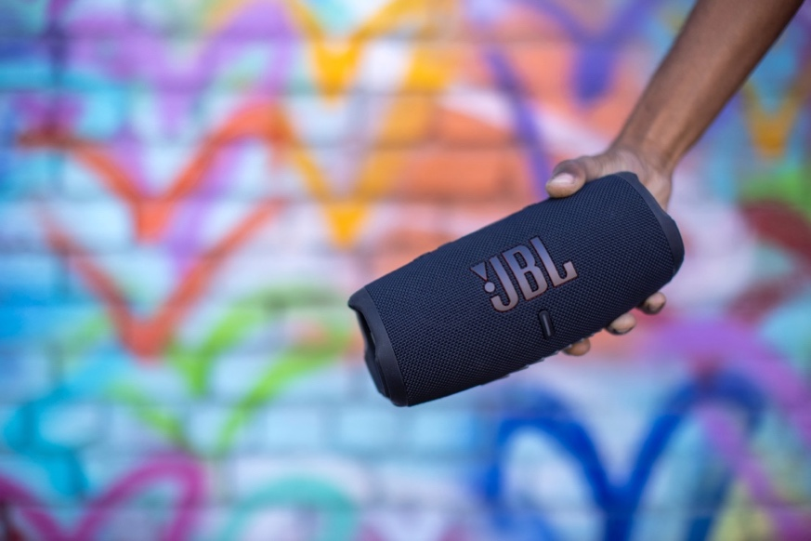

The latest addition to the popular JBL Charge series, the JBL Charge 5, is now available. Totally waterproof and dustproof, the speaker packs 20 hours of famous JBL Signature Pro Sound in a super rugged package. Complete with a new standout logo design and cool colourways, the JBL Charge 5 is here to make a statement.

With the Charge 5’s new and improved tech, you’ll enjoy the best sound in town. The speaker blasts epic JBL audio and deep bass for up to 20 hours. The built-in power bank that made the Charge Series so popular charges phones and other devices via USB, so you won’t run out of juice even when on the road or out camping. For the ultimate fiesta feeling, connect multiple JBL portable speakers together with the PartyBoost function.

The latest generation of the JBL Charge series features silicon bumpers and an eye-catching JBL logo, for a hot new spin on JBL’s iconic design. Now even more durable, you know the music will never stop, not even when we’re back on our wildest adventures again.

The JBL Charge 5 is available now in Black, Blue, Green, Grey, Red, Pink, Teal, Camo and White in selected Retailers and Authorized Resellers for 199,00€. More information on Charge 5 can be found at www.jblgreece.gr.

**About WaveMotion**

WaveMotion, an importer and distributor, is seated in Athens Greece, operating on a wholesale basis, in the consumer electronics, telecommunications and computer industry for over 35 years. WaveMotion S.A. retains the official, exclusive, distribution for the Greek market of important Houses- in leading positions in the Global Arena, like JBL, harman/kardon, Cambridge Audio, Q Acoustics, QED, Goldring, rapoo.

Brand Development is the core skill of WaveMotion Team. The vision of our people is to expand WaveMotion’s Brands selection, following our tagline’s principles –Technology, Aesthetics, Design- and continue this journey of Ours, introducing compellingly and establishing decisively these Brands, in the eyes of our Customers.

**About HARMAN**

HARMAN (harman.com) designs and engineers connected products and solutions for automakers, consumers, and enterprises worldwide, including connected car systems, audio and visual products, enterprise automation solutions; and services supporting the Internet of Things. With leading brands including AKG®, Harman Kardon®, Infinity®, JBL®, Lexicon®, Mark Levinson® and Revel®, HARMAN is admired by audiophiles, musicians and the entertainment venues where they perform around the world. More than 50 million automobiles on the road today are equipped with HARMAN audio and connected car systems. Our software services power billions of mobile devices and systems that are connected, integrated and secure across all platforms, from work and home to car and mobile. HARMAN has a workforce of approximately 30,000 people across the Americas, Europe, and Asia. In March 2017, HARMAN became a wholly-owned subsidiary of Samsung Electronics Co., Ltd..