For more information: Press Release
WaveMotion S.A For direct publication
Τηλ.:210-9244505 Hμ.:
Fax: 211-0123494
Email: Partners@WaveMotion.gr

harman/kardon Onyx Studio 7:
New modernized version of iconic Onyx Series
features updated industrial design and stereo sound

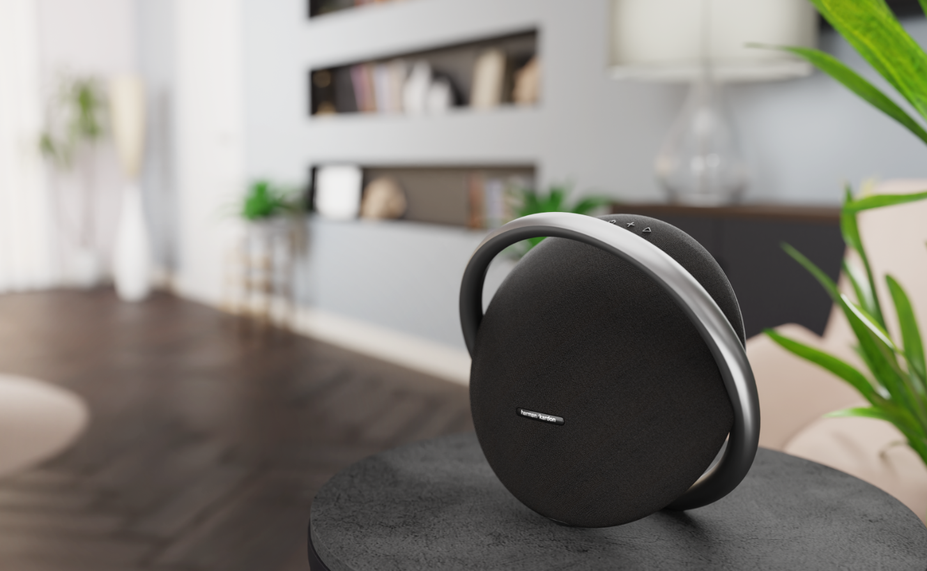

Harman Kardon continues to expand its award-winning Onyx Series with the addition of the Harman Kardon Onyx Studio 7. The latest Bluetooth speaker features superior stereo performance sound and an artful industrial design for the most discerning audio consumers.

The Harman Kardon Onyx Studio 7 comes enhanced with two 25mm dual tweeters for true stereo sound, combined with powerful bass and a Built-in Li-on rechargeable battery that provides 8 hours of playtime. To elevate the listening experience, music enthusiasts can pair two sets of Onyx Studio 7 using the Harman Kardon wireless Dual Sound feature.

Its elegant round silhouette is crafted from premium materials featuring a sleek, die-cast anodized aluminum carrying handle for easy portability. The Onyx Studio 7 is available in three color options - Charcoal Black, Marine Blue and Winter Gray, combining easy portability with an enhanced, modern look.

“The Harman Kardon Onyx Studio 7 is a modernized addition to our award-winning collection,” said Rodney Chan, VP and GM for Harman Home Audio. “It sounds as great as it looks, and we’re excited to add this one to the popular Onyx collection.”

The Harman Kardon Onyx Studio 7 is now available in black, grey and blue in selected Retailers and Authorized Resellers for 279,00€. More information on Onyx Studio 7 can be found at https://harmankardongreece.gr/

About WaveMotion
WaveMotion, an importer and distributor, is seated in Athens Greece, operating on a wholesale basis, in the consumer electronics, telecommunications and computer industry for over 35 years. WaveMotion S.A. retains the official, exclusive, distribution for the Greek market of important Houses- in leading positions in the Global Arena, like JBL, harman/kardon, Cambridge Audio, Q Acoustics, QED, Goldring, rapoo.
Brand Development is the core skill of WaveMotion Team. The vision of our people is to expand WaveMotion’s Brands selection, following our tagline’s principles –Technology, Aesthetics, Design- and continue this journey of Ours, introducing compellingly and establishing decisively these Brands, in the eyes of our Customers.

About HARMAN
HARMAN (harman.com) designs and engineers connected products and solutions for automakers, consumers, and enterprises worldwide, including connected car systems, audio and visual products, enterprise automation solutions; and services supporting the Internet of Things. With leading brands including AKG®, Harman Kardon®, Infinity®, JBL®, Lexicon®, Mark Levinson® and Revel®, HARMAN is admired by audiophiles, musicians and the entertainment venues where they perform around the world. More than 50 million automobiles on the road today are equipped with HARMAN audio and connected car systems. Our software services power billions of mobile devices and systems that are connected, integrated and secure across all platforms, from work and home to car and mobile. HARMAN has a workforce of approximately 30,000 people across the Americas, Europe, and Asia. In March 2017, HARMAN became a wholly-owned subsidiary of Samsung Electronics Co., Ltd..

