Για Περισσότερες Πληροφορίες: Δελτίο Τύπου
WaveMotion Α.Ε. Για άμεση Δημοσίευση
Τηλ.:210-9244505 Hμ.:
Fax: 210-9234273
Email: Partners@WaveMotion.gr

Introducing the Citation Series: Beautifully Designed, Smart, Configurable Home Audio Speaker System from Harman/Kardon®


Today’s discerning audio consumer is seeking sophisticated design and innovative technology that seamlessly blends with their daily lives. When it comes to a multi-room speaker system that means: ease of use, designs that fit every room in the home, superior sound, and access to the latest technologies and streaming services. For more than 65 years, Harman Kardon has been the leading audio engineering and design expert, captivating ears and hearts throughout generations, and the Harman Kardon Citation Series represents its latest feat. Combining an innovative acoustic design delivering remarkable audio quality with cutting-edge technologies - including the Google Assistant, a high-resolution LCD touch screen and Chromecast built-in - the Citation Series represent the next generation of home speakers.

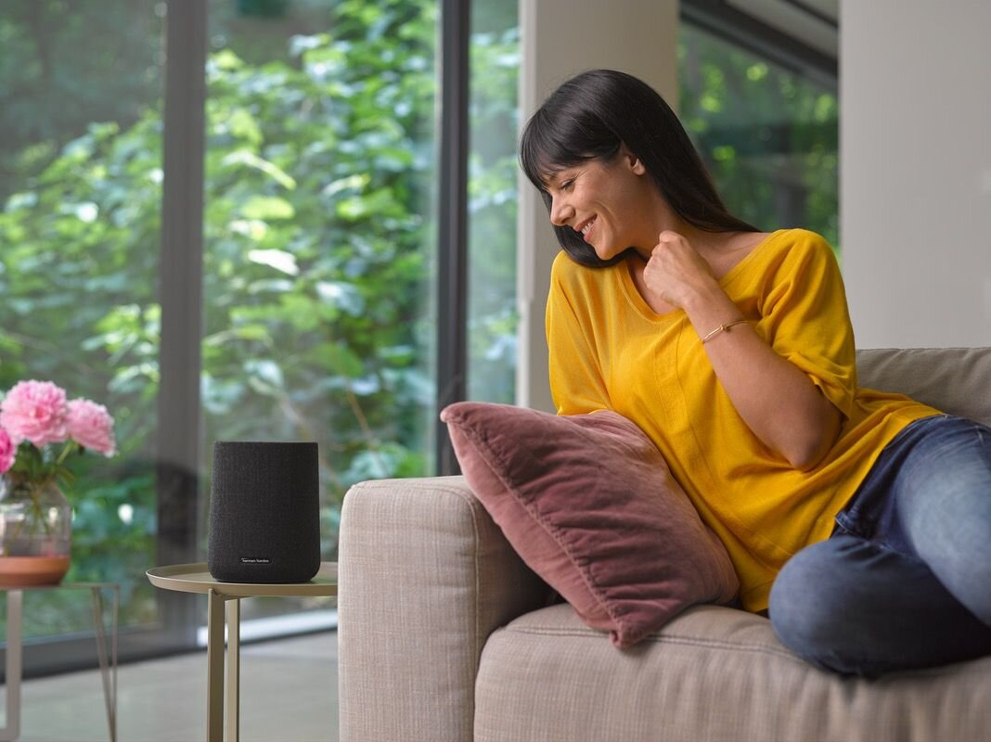
From a design perspective, the sophistication shown in the Harman Kardon Citation Series is unmatched. The speakers feature the brand’s signature industrial design accented with thoughtful elements, including elegant aluminum detailing. Bringing the refined and sleek look together is the Winter Gray or Classic Black wool fabric from Kvadrat, the European leader in acoustic textiles, that are dirt-repellant and flame-retardant. This timeless design marries Harman Kardon’s expertise in sound engineering and technology with the style and sleekness of Kvadrat.

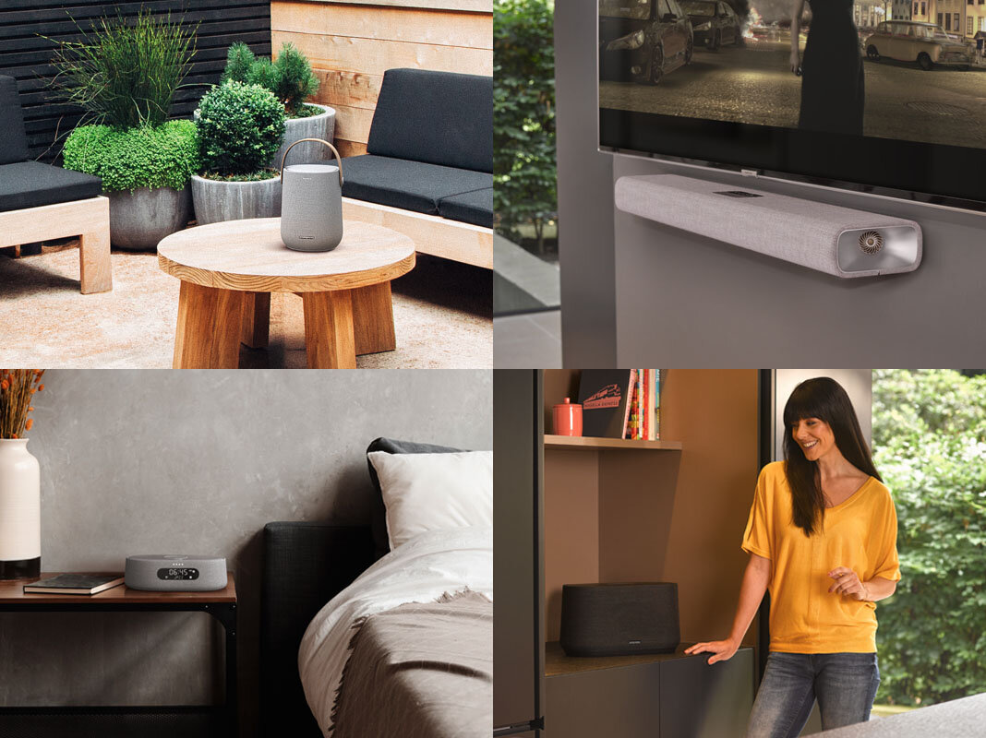
The Citation Series deliver a dynamic listening experience, with options to use the speakers individually or build a powerful 5.1-channel surround sound system. Their multi-room capabilities allow for the control of amazing sound from any room, either playing from one music source or playing different tracks in different rooms. To round out the incredible audio performance and extraordinary design, Citation also features Google Assistant. Streaming the newest or most popular music is now quick and efficient with Google’s intelligent voice-activation. Smart voice control also makes tackling tasks as simple as saying “Hey Google,” to create calendar reminders, generate to-do lists, get the latest forecast, control smart home devices* and more.

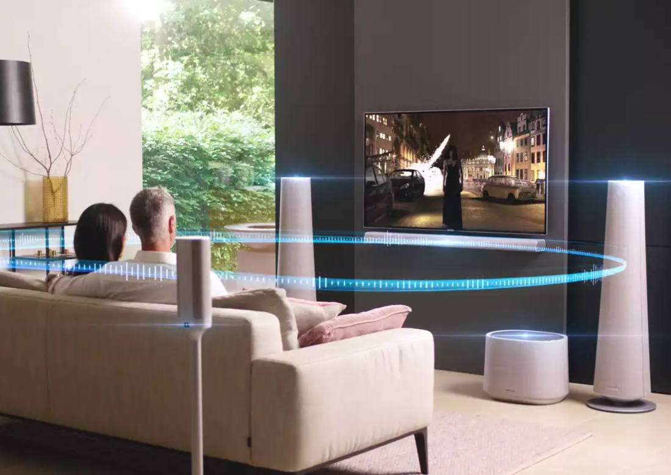
“Consumers increasingly look to their home entertainment systems to do more than just play music,” said Michael Mauser, President, Lifestyle Audio at HARMAN. “While features like voice control and multi-room streaming are becoming standard, the Harman Kardon Citation Series is anything but. The pairing of our unprecedented audio legacy and premium design with smart features and ease of use gives Citation speakers the opportunity to truly transform the listening experience.” Additionally, Harman Kardon Citation speakers have Chromecast built-in, allowing over 300 audio and video streaming services to be easily accessed in HD quality. Once connected on the same Wi-Fi network as a Citation speaker, a smartphone, tablet or laptop can “cast” the latest chart-topping release or playlist from Chromecast-compatible apps.

The Citation speaker lineup consists of various options to meet every listening need, including multiple countertop speaker options, a soundbar, powered subwoofer and a pair of tower speakers. The Citation Series is available since early November, in selected Retailers and Authorized Resellers. The Citation Series will be priced from €199,00 – € 2.499,00
More information on the Citation Series can be found at www.wavemotion.gr/el/citation-story-page

About WaveMotion
WaveMotion, an importer and distributor, is seated in Athens Greece, operating on a wholesale basis, in the consumer electronics, telecommunications and computer industry for over 35 years. WaveMotion S.A. retains the official, exclusive, distribution for the Greek market of important Houses- in leading positions in the Global Arena, like JBL, harman/kardon, Cambridge Audio, Q Acoustics.
Brand Development is the core skill of WaveMotion Team. The vision of our people is to expand WaveMotion’s Brands selection, following our tagline’s principles –Technology, Aesthetics, Design- and continue this journey of Ours, introducing compellingly and establishing decisively these Brands, in the eyes of our Customers.

About HARMAN
HARMAN (harman.com) designs and engineers connected products and solutions for automakers, consumers, and enterprises worldwide, including connected car systems, audio and visual products, enterprise automation solutions; and services supporting the Internet of Things. With leading brands including AKG®, Harman Kardon®, Infinity®, JBL®, Lexicon®, Mark Levinson® and Revel®, HARMAN is admired by audiophiles, musicians and the entertainment venues where they perform around the world. More than 50 million automobiles on the road today are equipped with HARMAN audio and connected car systems. Our software services power billions of mobile devices and systems that are connected, integrated and secure across all platforms, from work and home to car and mobile. HARMAN has a workforce of approximately 30,000 people across the Americas, Europe, and Asia. In March 2017, HARMAN became a wholly-owned subsidiary of Samsung Electronics Co., Ltd.

