**For more information: Press Release**

**WaveMotion S.A** For direct publication

Τηλ.:210-9244505 Hμ.: 17/09/2020

Fax: 211-0123494

Email: [Partners@WaveMotion.gr](mailto:Partners@WaveMotion.gr)

***«“Sound is Survival”***

***Get the ultimate edge with JBL Quantum gaming range***

**Athens, September 17, 2020** - Gamers, get ready to become unstoppable!

JBL’s first ever headset range and PC speaker created exclusively for gamers is now available. JBL Quantum has arrived. Game Changed.

In gaming, every sound matters so it’s time for the industry leader in sound to lead the way. The JBL Quantum range is engineered for the most realistic sound experience ever in a gaming headset. Amplifying every audible detail with pinpoint accuracy and immersive sound for a true competitive advantage, thanks to JBL QuantumSOUND Signature™. From the thrill of tracking enemies in FPS games, to engaging in epic MOBA battles, the JBL Quantum range brings game-winning audio.

**Your instincts, heightened**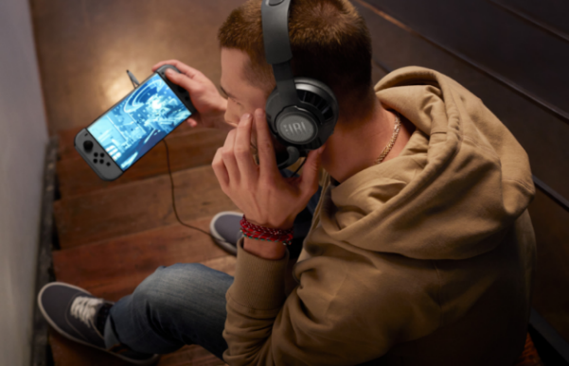. The flagship JBL Quantum ONE takes sound to the next level, built exclusively with JBL’s own QuantumSPHERE 360™ sound tech. Extensively tested with gamers around the world, the head tracker sensors and spatial audio will precisely locate and pair visual objects with their sound. Feel the action and any movement around you like never before.

**Amplify every moment**. The next generation of gaming immersion is here. Sound typically moves on a horizontal plane, but JBL’s sound algorithms elevate virtual world experiences to new dimensions by adding overhead channels. The result: JBL QuantumSURROUNDTM. Sound technology powered by the JBL QuantumENGINETM PC software that creates a wider, more realistic spatial soundstage and features in the JBL Quantum 300, 400, 600 and 800 headsets.

**Dominate the game**. Background noise won’t get in the way of crystal-clear comms. JBL Quantum series also boasts pro-level flip-up or detachable voice focus boom microphones with echo cancelling. Every model is lightweight and has memory foam ear cushions for long-lasting comfort. JBL Quantum 800 and Quantum ONE also pack active noise cancellation so however noisy your environment, your focus will stay in game.

**Perfect partner.** The entire JBL Quantum range is optimized for PC, with the JBL Quantum ONE as the ultimate, dedicated PC gaming headset. All models in the range are compatible for console and mobile, as well as compatible with Discord, TeamSpeak and Skype, whether you're calling for backup or bragging about your performance, with JBL Quantum, your teammates will hear loud and clear.

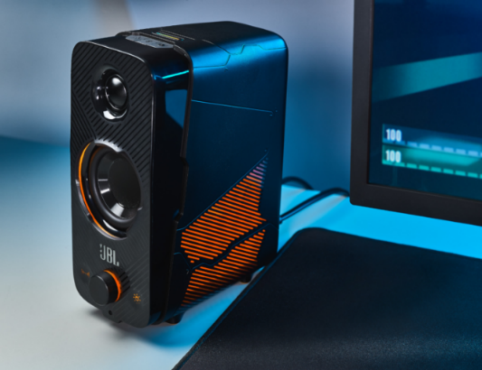**Go even deeper into the action**. The JBL Quantum DUO PC speaker complements the headset range and pairs JBL’s dynamic surround sound with Dolby Digital. Players can easily pinpoint incoming fire and feel the roar of explosive action. Exposed drivers and tweeters deliver incredible sound clarity, so you’ll never miss a shot during gameplay. JBL Quantum DUO’s unique lighting effects supercharge the gaming rig. Like the rest of the JBL Quantum Series, the JBL Quantum DUO is fully compatible with any gaming system.

**Ready to conquer the game?** The entire JBL Quantum Series is available since early September, in selected Retailers and Authorized Resellers. The JBL Quantum headsets will be priced from €49,95 – €249,00 and the JBL Quantum DUO will be available for €179,00 €.

More information on the JBL Quantum Range can be found at www.jblgreece.gr.

**About WaveMotion**

WaveMotion, an importer and distributor, is seated in Athens Greece, operating on a wholesale basis, in the consumer electronics, telecommunications and computer industry for over 35 years. WaveMotion S.A. retains the official, exclusive, distribution for the Greek market of important Houses- in leading positions in the Global Arena, like JBL, harman/kardon, Cambridge Audio, Q Acoustics.

Brand Development is the core skill of WaveMotion Team. The vision of our people is to expand WaveMotion’s Brands selection, following our tagline’s principles –Technology, Aesthetics, Design- and continue this journey of Ours, introducing compellingly and establishing decisively these Brands, in the eyes of our Customers.

**About HARMAN**

HARMAN (harman.com) designs and engineers connected products and solutions for automakers, consumers, and enterprises worldwide, including connected car systems, audio and visual products, enterprise automation solutions; and services supporting the Internet of Things.  With leading brands including AKG®, Harman Kardon®, Infinity®, JBL®, Lexicon®, Mark Levinson® and Revel®, HARMAN is admired by audiophiles, musicians and the entertainment venues where they perform around the world. More than 50 million automobiles on the road today are equipped with HARMAN audio and connected car systems. Our software services power billions of mobile devices and systems that are connected, integrated and secure across all platforms, from work and home to car and mobile. HARMAN has a workforce of approximately 30,000 people across the Americas, Europe, and Asia. In March 2017, HARMAN became a wholly-owned subsidiary of Samsung Electronics Co., Ltd.