For more information: Press Release
WaveMotion S.A For immediate publication
Τηλ.:210-9244505 Date.: April 8th, 2020
Fax: 211-0123494
Email: Partners@WaveMotion.gr

JBL Easter Campaign: We ‘re in this together

Wednesday, April 8th, 2020. WaveMotion S.A. official Distributor of JBL Lifestyle offerings for the Greek market, announces its launch of JBL Easter Campaign. The Campaign will start on April 8th and will run through the pre- Orthodox Easter period and has been designed and implemented by Jetdrops Digital Agency. The Campaign will be based fully on Social Media on a massive scale and will target Greek users of Facebook and Instagram, estimating to generate a total of 4.200.000 impressions.
The Scope of the Campaign is to enhance JBL Brand awareness, bring JBL lifestyle offerings to the audience’s awareness and drive sales. Because of the strict lockdown that Greek consumers are facing with, campaign boosts people’s mood and help them stay happy, through music related content. Furthermore, it facilitates ‘me moments’ at home, offering fun content and music related proposals. But ultimately gives voice to the JBL brand, through a meaningful role, as JBL wishes to support, inspire and motivate its fans.
The Concept of the campaign is simple:
JBL listens… what you choose to listen
Music is global and yet, it is personal. JBL supports any music taste.
JBL is a global love brand, bringing epic sound to anyone selecting a JBL product. JBL is well established for bringing the sound to the consumer, wherever he/she chooses to listen to music. NOW, that the daily life has changed and everyone has to adapt, JBL speaks out to support JBL fans and everyone else, urging them to listen to music at home so as to feel a little bit better, less lonely and stressed. JBL supports any kind of music, at any home, during any activity, any time of the day! During the lockdown JBL’s global tagline is:
We’ re in this together!
The Audience of the Campaign is Anyone who listens to music at home! And the estimate impression numbers at 4.200.000.
The Demographics of the Campaign are:
-Audience 15-18yo: 160.000 in total // Est. impressions 300.000 (school students that live with parents)
-Audience 18-24yo: 860.000 in total // Est. impressions: 1.000.000 (uni students living with parents or alone in other cities, young couples, singles, uni students or young professionals living with roommates or alone)
-Audience 25-28yo, 28-35yo: 1.600.000 in total // Est. impressions: 1.800.000 impressions (young professionals, unemployed or with low income living with family, singles living alone or with roommates, young couples, young families with toddlers)
-Audience 35-45yo:1.500.000 in total // Est. impressions 1.100.000 (senior professionals, singles, couples, families)
The Campaign is based on several custom designs to spread the word. Local language, local messaging, various ‘music at home’ moments and occasions, music for any taste and JBL products linked with every ‘listening’ occasion.
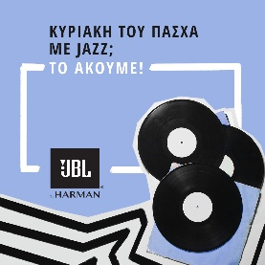
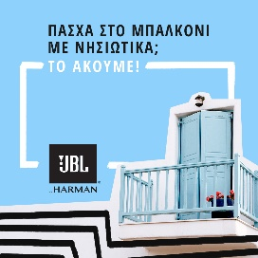


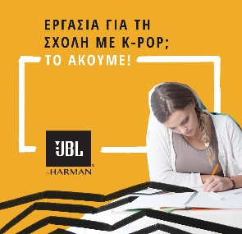
The visuals are categorized per audience, so as to address individuals that would feel familiar with the content or that would see themselves on the occasions. All visuals are dynamically added in the Ad Campaign, per audience, with multiple specs and various targeting filters, for the best reach possible.

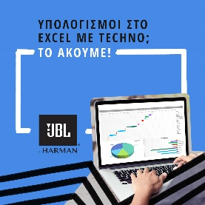
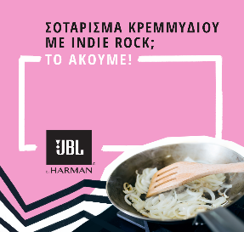
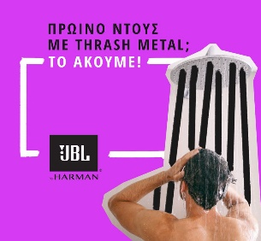
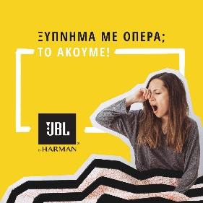
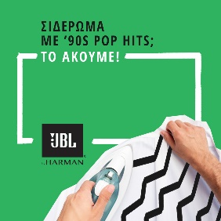
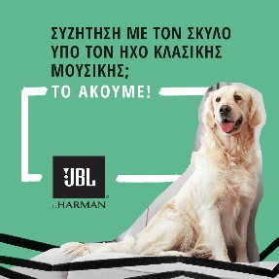

About WaveMotion
WaveMotion, an importer and distributor, is seated in Athens Greece, operating on a wholesale basis, in the consumer electronics, telecommunications and computer industry for over 35 years. WaveMotion S.A. retains the official, exclusive, distribution for the Greek market of important Houses- in leading positions in the Global Arena, like JBL, harman/kardon, Cambridge Audio, Q Acoustics.
Brand Development is the core skill of WaveMotion Team. The vision of our people is to expand WaveMotion’s Brands selection, following our tagline’s principles –Technology, Aesthetics, Design- and continue this journey of Ours, introducing compellingly and establishing decisively these Brands, in the eyes of our Customers.
About jetdrops (www.jetdrops.com/)
Starting as a social media consulting agency, jetdrops has now evolved into a full-blown Digital & PR agency able to support its partners across their communication spectrum.
From brand design, communication & digital strategy, media relations and event planning, to YouTube content production and big data analytics, delivering measured results, evolving day by day and providing tangible value to partners, stand at the forefront of jetdrops' philosophy.
About HARMAN
HARMAN (harman.com) designs and engineers connected products and solutions for automakers, consumers, and enterprises worldwide, including connected car systems, audio and visual products, enterprise automation solutions; and services supporting the Internet of Things. With leading brands including AKG®, Harman Kardon®, Infinity®, JBL®, Lexicon®, Mark Levinson® and Revel®, HARMAN is admired by audiophiles, musicians and the entertainment venues where they perform around the world. More than 50 million automobiles on the road today are equipped with HARMAN audio and connected car systems. Our software services power billions of mobile devices and systems that are connected, integrated and secure across all platforms, from work and home to car and mobile. HARMAN has a workforce of approximately 30,000 people across the Americas, Europe, and Asia. In March 2017, HARMAN became a wholly-owned subsidiary of Samsung Electronics Co., Ltd.

