**For more information: Press Release**

**WaveMotion S.A** For direct publication

Τηλ.:210-9244505 Hμ.:2/8/2019

Fax: 211-0123494

Email: [Partners@WaveMotion.gr](mailto:Partners@WaveMotion.gr)

***Listen Up, Music Lovers:***

***The JBL® Flip 5 Is Nothing Short of Epic***

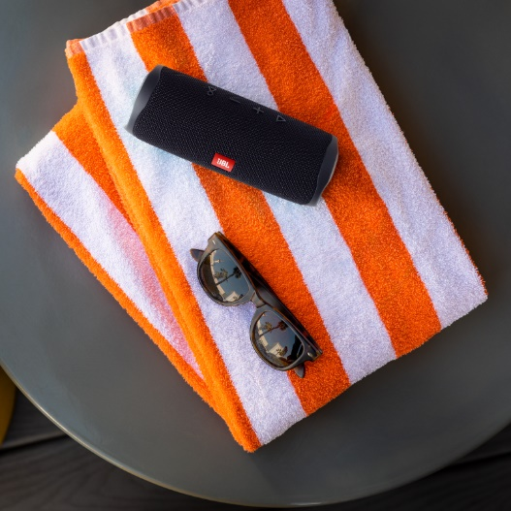Crank the music up, because JBL’s award-winning Flip series is redefining great sound. Enter the JBL Flip 5, the newest member of the popular Bluetooth speaker line that takes the portable listening experience to the next level. The combination of crystal-clear sound, packaged in a waterproof and durable case, promises an epic sound experience that will fuel any party.

Looking for impressive sound that you can take anywhere? Say no more. The Flip 5 takes sound quality to new heights with an all new acoustic design. A newly engineered racetrack-shaped driver with increased cone area and excursion amplifies JBL’s classic signature sound, elevating the overall output of the music delivering crisp highs and deep bass.

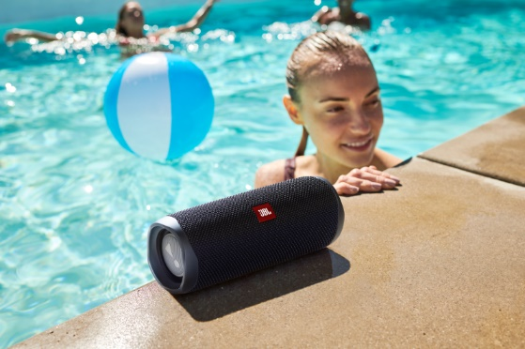Like its predecessor, the JBL Flip 5 sports a waterproof, compact design, which means there’s no stopping where this speaker can travel. Small enough to pack in a suitcase, bring it to mountaintop soirees and your beach excursions, no matter the weather. Boasting 12 hours of playtime and recharging capabilities via a new USB-C charging port means this speaker will be up and running with stronger battery support than ever before. A built-in speakerphone, alongside its stellar and stable Bluetooth connection, lets users make and receive crystal clear calls with the touch of a button.

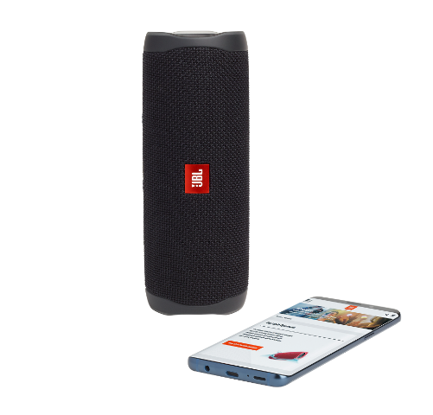 **JBL Flip 5 Features**

* Wireless Bluetooth Streaming
* 12 hours of playtime
* IPX7 Waterproof
* USB-C Charging
* Speakerphone
* Life-proof materials

**Pricing and Availability**

**The JBL® Flip 5**will be available in 6 color options: Grey Stone, Fiesta Red, Ocean Blue, Midnight Black, Steel White and Squad, at the suggested retail price of 129.00 €, in select retailers starting end of Αugust 2019.

**About WaveMotion**

WaveMotion, an importer and distributor, is seated in Athens Greece, operating on a wholesale basis, in the consumer electronics, telecommunications and computer industry for over 35 years. WaveMotion S.A. retains the official, exclusive, distribution for the Greek market of important Houses- in leading positions in the Global Arena.

Brand Development is the core skill of WaveMotion Team. The vision of our people is to expand WaveMotion’s Brands selection, following our tagline’s principles –Technology, Aesthetics, Design- and continue this journey of Ours, introducing compellingly and establishing decisively these Brands, in the eyes of our Customers.